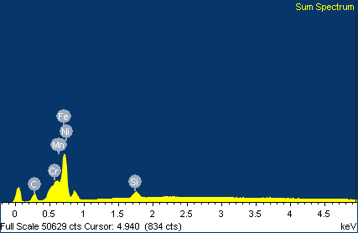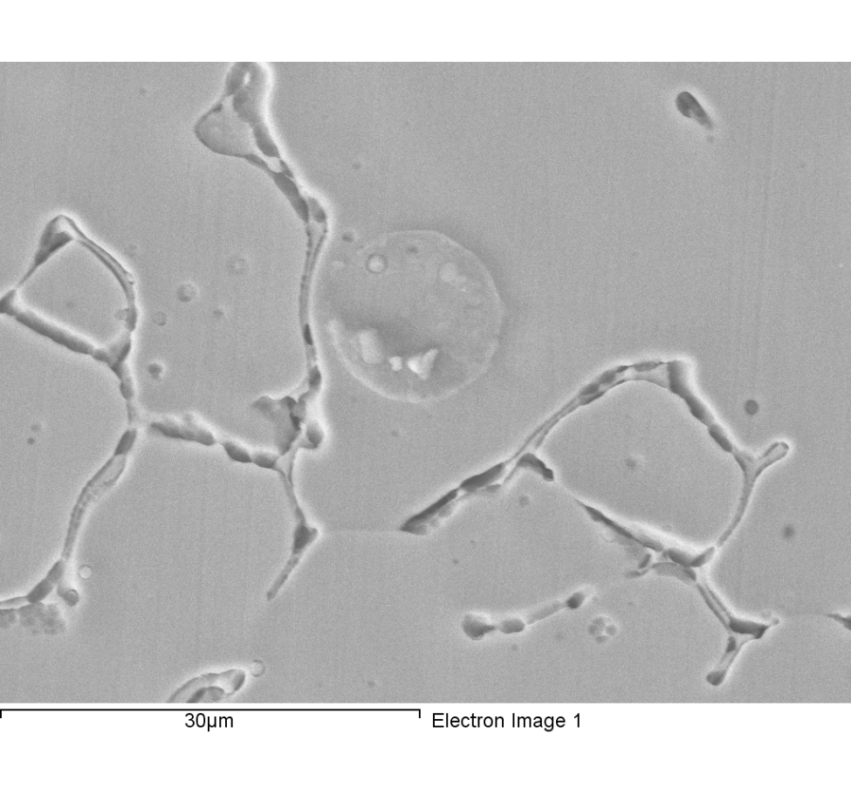

Comment: line 1-1 mapping-1

|  |  |  |  |
| --- | --- | --- | --- |
| Element | Weight% | Atomic% |  |
|  |  |  |  |
| C K | 7.55 | 27.10 |  |
| Si K | 0.92 | 1.42 |  |
| Cr K | 19.63 | 16.29 |  |
| Mn K | 1.51 | 1.18 |  |
| Fe K | 61.20 | 47.27 |  |
| Ni K | 9.19 | 6.75 |  |
|  |  |  |  |
| Totals | 100.00 |  |  |

1/18/2018 3:28:26 PM

Project 1

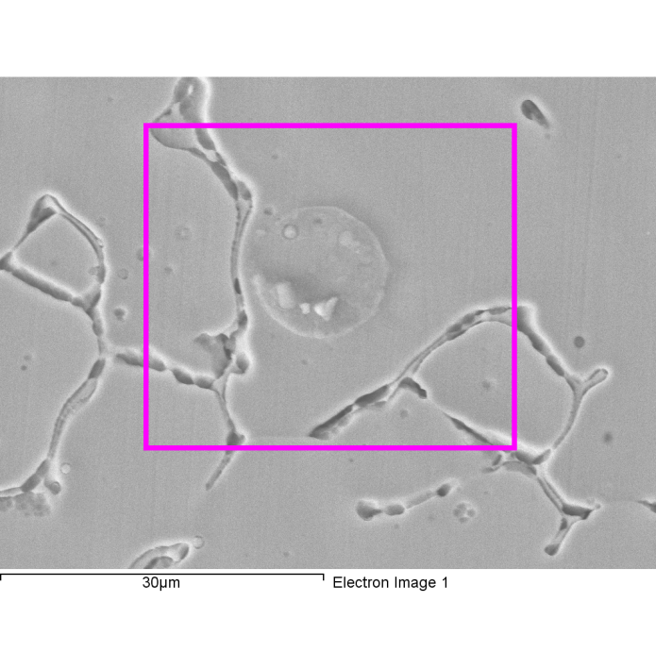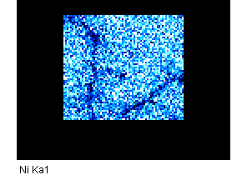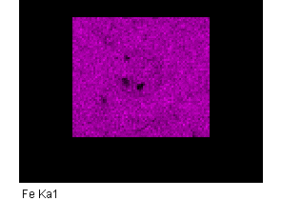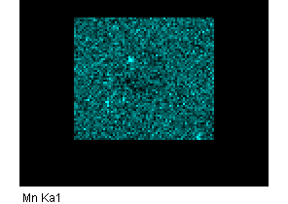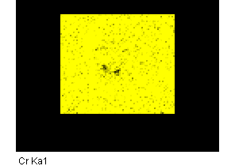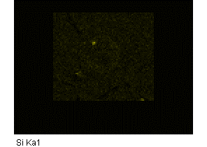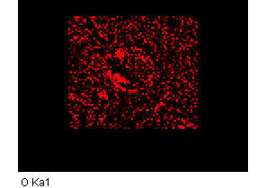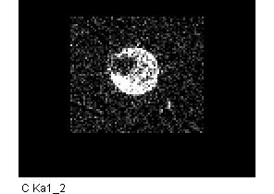

Comment: line 1-1 mapping-1

1/18/2018 3:28:46 PM

Project 1

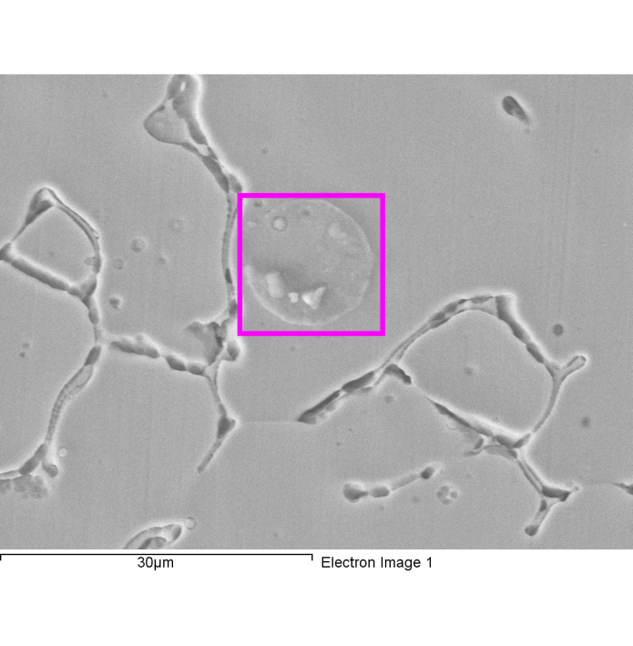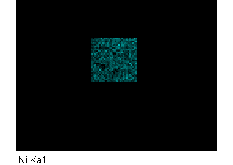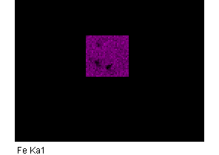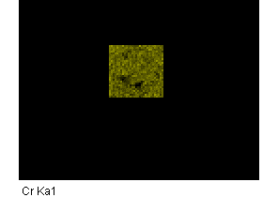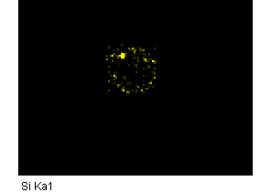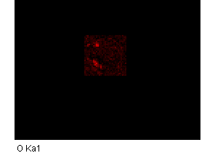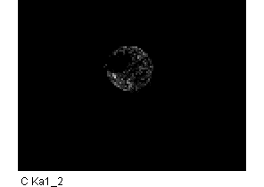

Comment:line1-1-mapping-2

1/18/2018 3:35:51 PM

Project 2

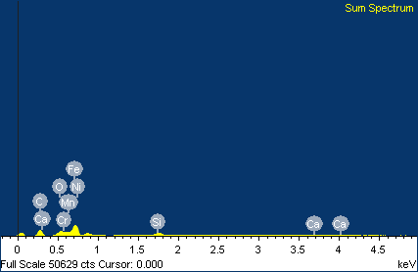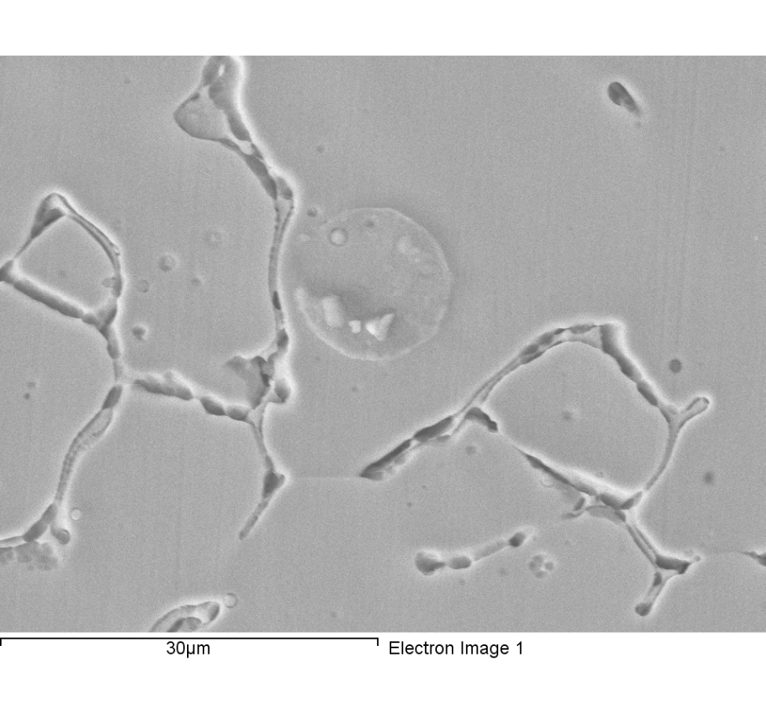

Comment:line1-1-mapping-2

|  |  |  |  |
| --- | --- | --- | --- |
| Element | Weight% | Atomic% |  |
|  |  |  |  |
| C K | 18.21 | 47.89 |  |
| O K | 3.38 | 6.68 |  |
| Si K | 1.02 | 1.14 |  |
| Ca K | 0.21 | 0.17 |  |
| Cr K | 16.20 | 9.84 |  |
| Mn K | 1.29 | 0.74 |  |
| Fe K | 51.62 | 29.20 |  |
| Ni K | 8.07 | 4.34 |  |
|  |  |  |  |
| Totals | 100.00 |  |  |

1/18/2018 3:36:07 PM

Project 2

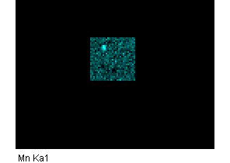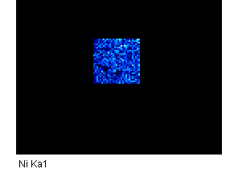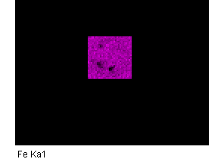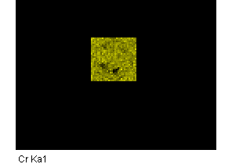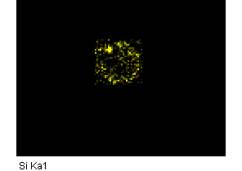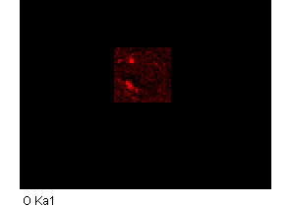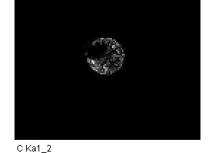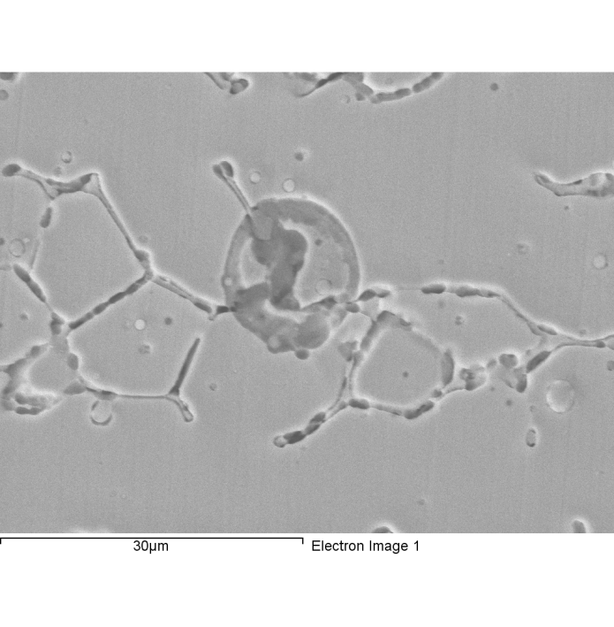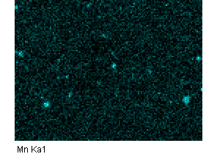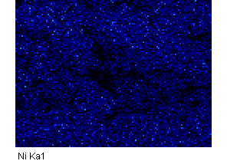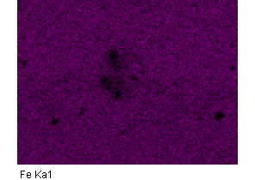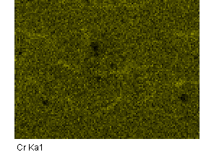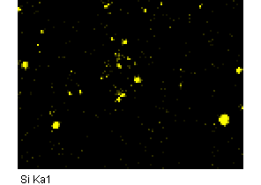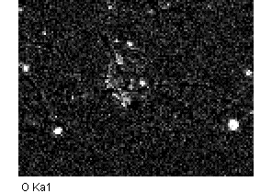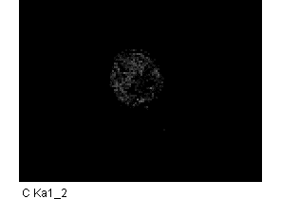

Comment:1-1-2

1/18/2018 3:37:38 PM

Project 2

Comment: line1-2-mapping-1

1/18/2018 3:45:58 PM

Project 2

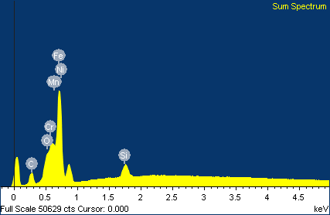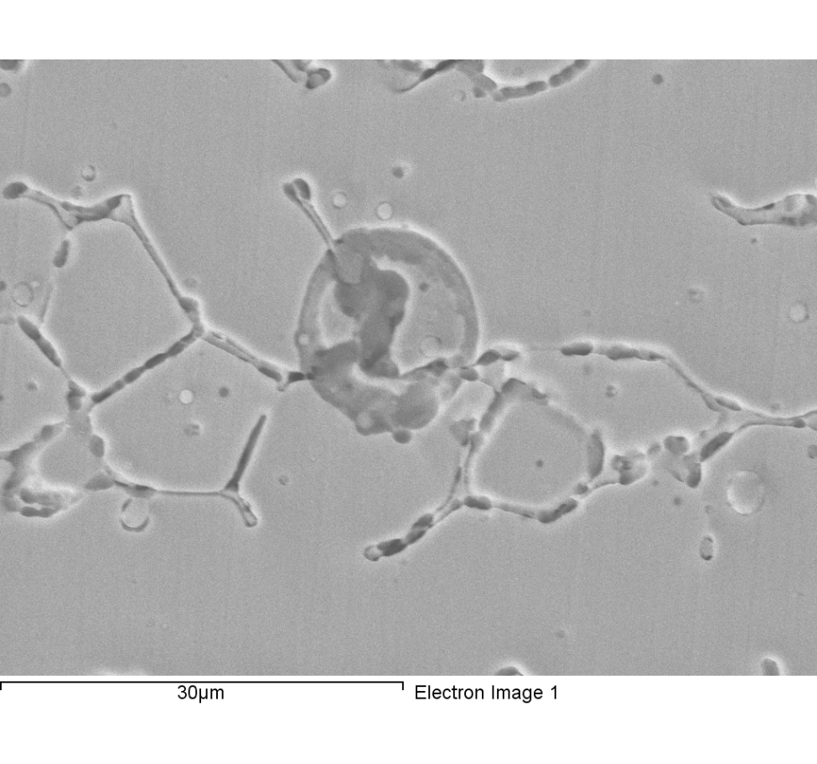

Comment: line1-2-mapping-1

|  |  |  |  |
| --- | --- | --- | --- |
| Element | Weight% | Atomic% |  |
|  |  |  |  |
| C K | 6.27 | 22.66 |  |
| O K | 1.52 | 4.13 |  |
| Si K | 0.96 | 1.49 |  |
| Cr K | 19.73 | 16.46 |  |
| Mn K | 1.61 | 1.27 |  |
| Fe K | 61.02 | 47.42 |  |
| Ni K | 8.88 | 6.56 |  |
|  |  |  |  |
| Totals | 100.00 |  |  |

1/18/2018 3:46:10 PM

Project 2

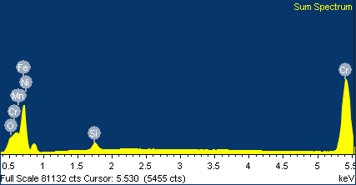

|  |  |  |  |
| --- | --- | --- | --- |
| Element | Weight% | Atomic% |  |
|  |  |  |  |
| C K | 6.27 | 22.66 |  |
| O K | 1.52 | 4.13 |  |
| Si K | 0.96 | 1.49 |  |
| Cr K | 19.73 | 16.46 |  |
| Mn K | 1.61 | 1.27 |  |
| Fe K | 61.02 | 47.42 |  |
| Ni K | 8.88 | 6.56 |  |
|  |  |  |  |
| Totals | 100.00 |  |  |

Comment: line1-2-mapping-2

1/18/2018 3:47:08 PM

Project 2

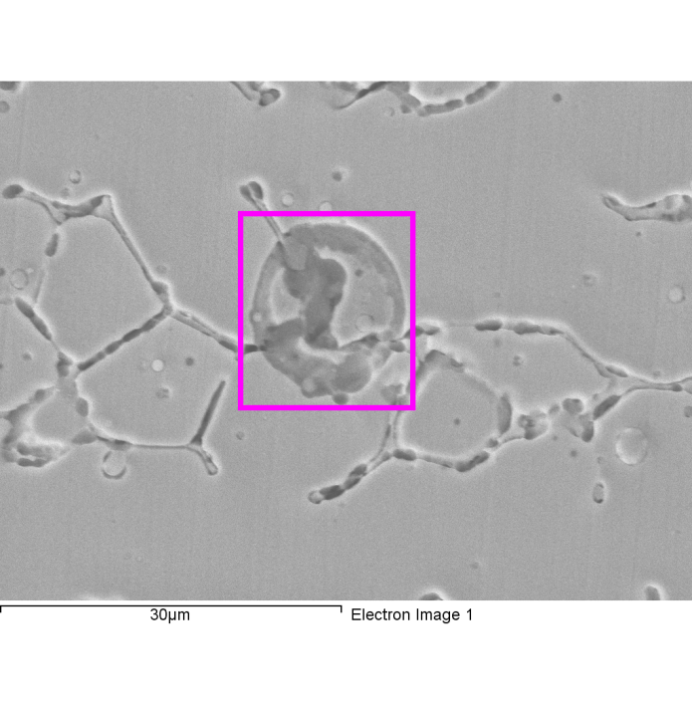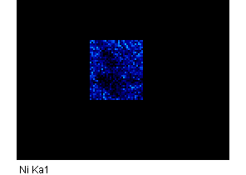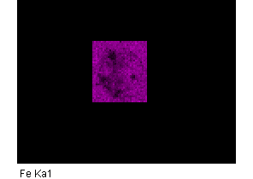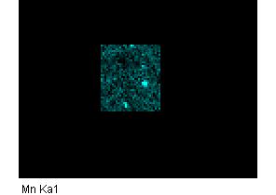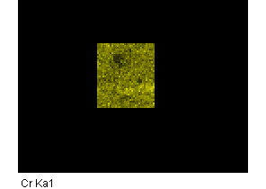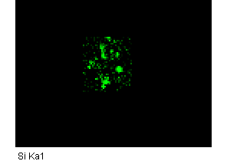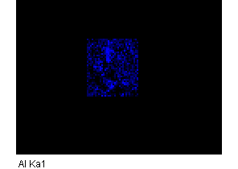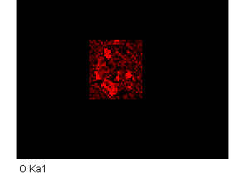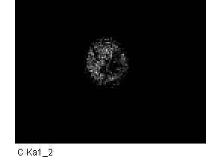

Comment:line1-2-mapping-2

1/18/2018 3:50:02 PM

Project 2

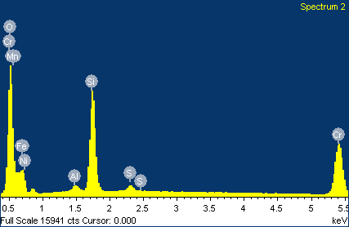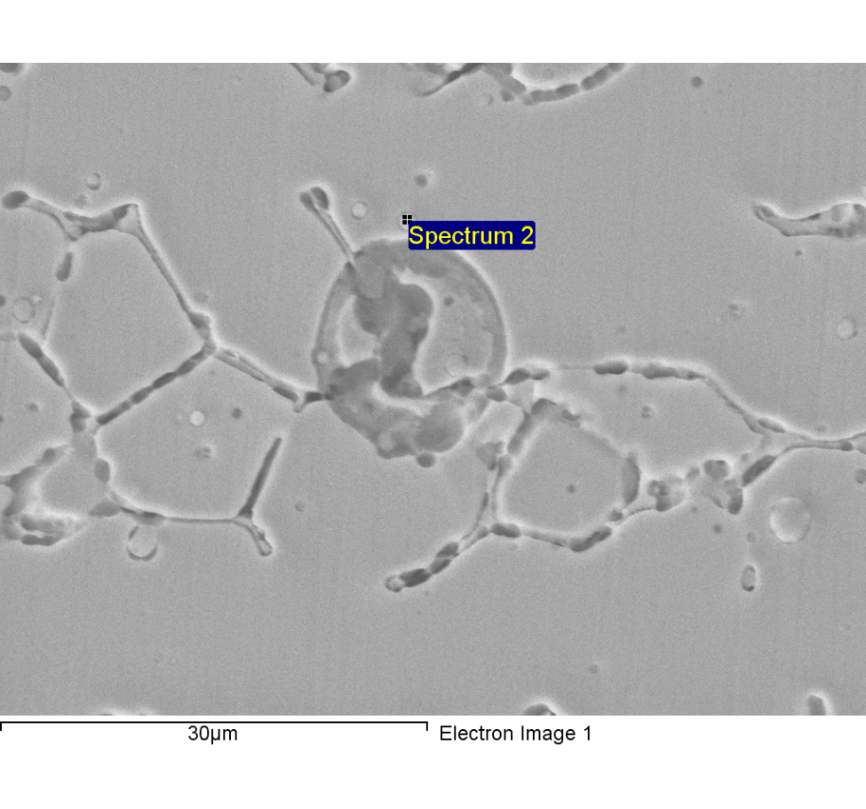

Comment:line1-2-point scan-2

|  |  |  |  |
| --- | --- | --- | --- |
| Element | Weight% | Atomic% |  |
|  |  |  |  |
| C K | 7.95 | 18.17 |  |
| O K | 25.45 | 43.68 |  |
| Al K | 0.57 | 0.58 |  |
| Si K | 9.23 | 9.02 |  |
| S K | 0.55 | 0.47 |  |
| Cr K | 11.27 | 5.95 |  |
| Mn K | 12.92 | 6.46 |  |
| Fe K | 28.01 | 13.77 |  |
| Ni K | 4.05 | 1.90 |  |
|  |  |  |  |
| Totals | 100.00 |  |  |

1/18/2018 3:58:12 PM

Project 2

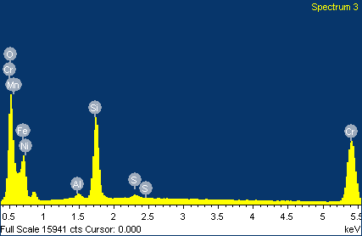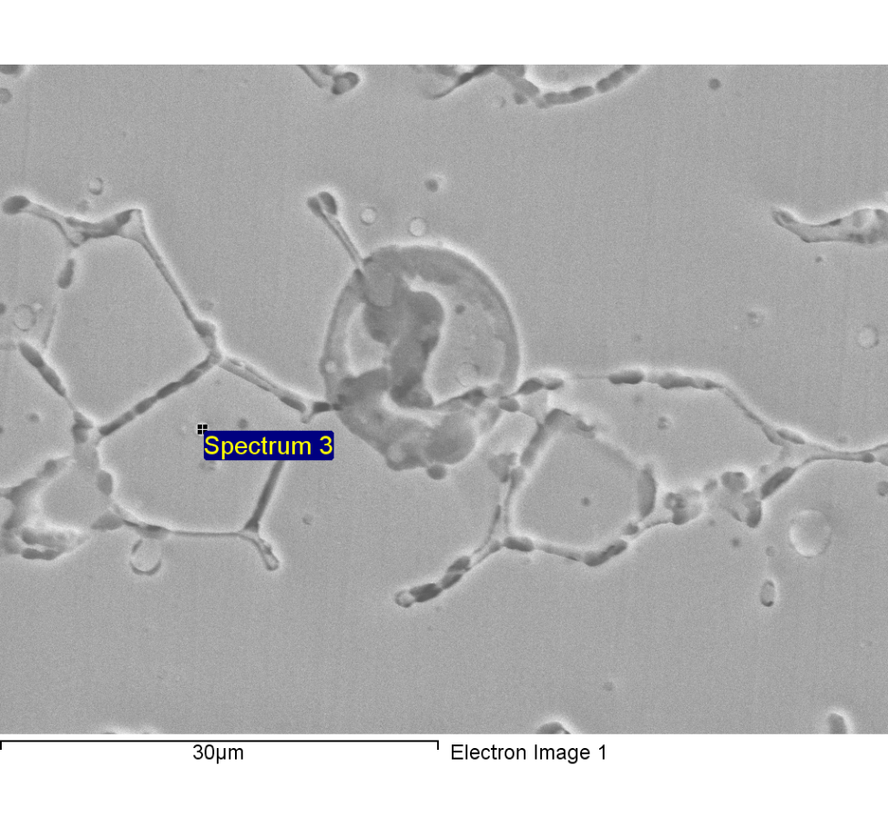

Comment:line1-2-point scan-3

|  |  |  |  |
| --- | --- | --- | --- |
| Element | Weight% | Atomic% |  |
|  |  |  |  |
| C K | 5.79 | 15.03 |  |
| O K | 19.47 | 37.93 |  |
| Al K | 0.51 | 0.59 |  |
| Si K | 8.00 | 8.88 |  |
| S K | 0.31 | 0.30 |  |
| Cr K | 13.45 | 8.06 |  |
| Mn K | 8.75 | 4.96 |  |
| Fe K | 38.19 | 21.31 |  |
| Ni K | 5.53 | 2.93 |  |
|  |  |  |  |
| Totals | 100.00 |  |  |

1/18/2018 3:58:22 PM

Project 2

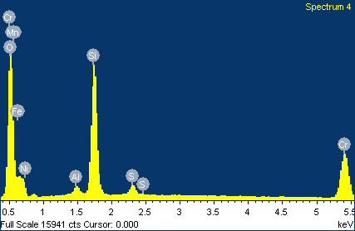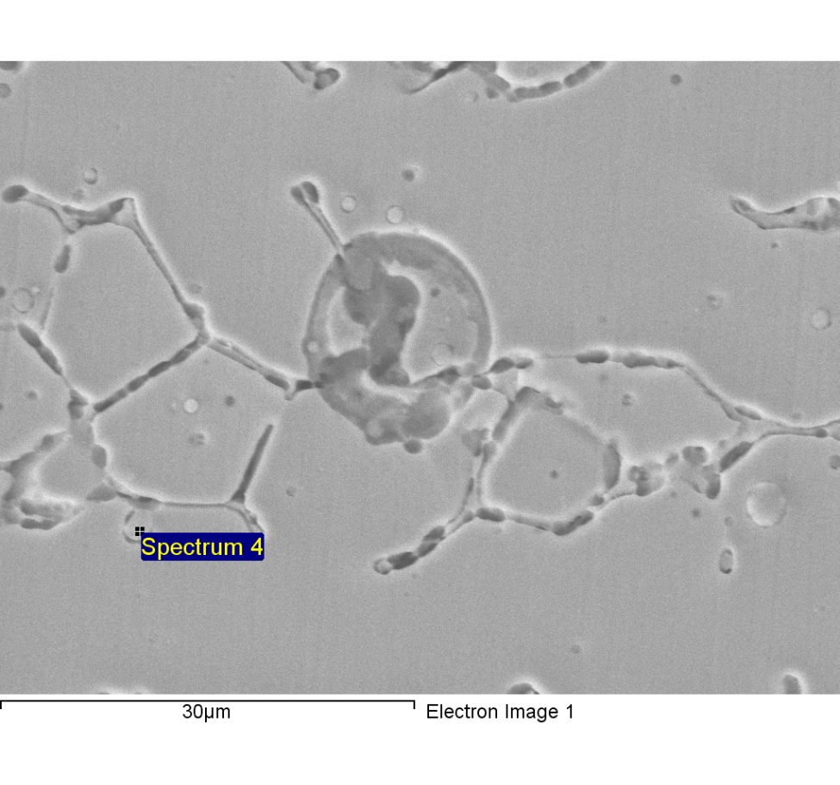

Comment:line1-2-point scan-4

|  |  |  |  |
| --- | --- | --- | --- |
| Element | Weight% | Atomic% |  |
|  |  |  |  |
| C K | 4.83 | 10.97 |  |
| O K | 29.49 | 50.23 |  |
| Al K | 0.73 | 0.74 |  |
| Si K | 11.65 | 11.30 |  |
| S K | 0.87 | 0.74 |  |
| Cr K | 9.85 | 5.16 |  |
| Mn K | 18.32 | 9.09 |  |
| Fe K | 21.57 | 10.52 |  |
| Ni K | 2.69 | 1.25 |  |
|  |  |  |  |
| Totals | 100.00 |  |  |

1/18/2018 3:58:34 PM

Project 2

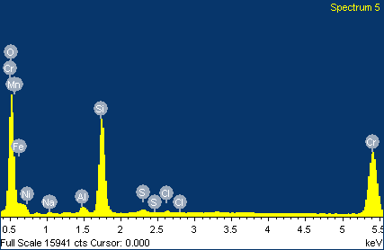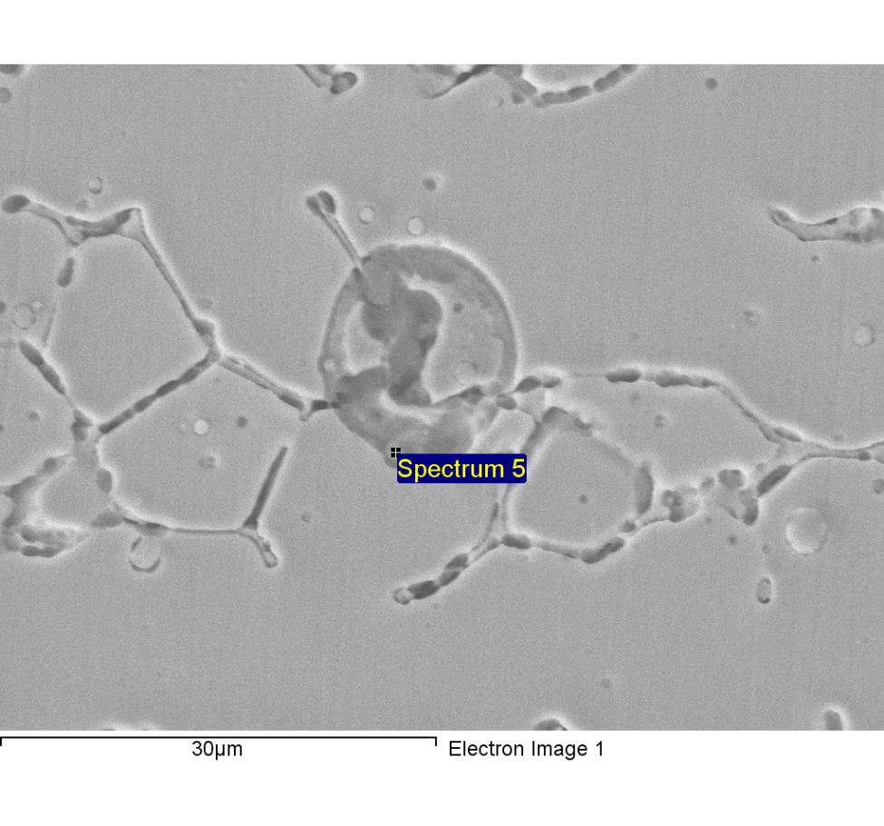

Comment:line1-2-point scan-5

|  |  |  |  |
| --- | --- | --- | --- |
| Element | Weight% | Atomic% |  |
|  |  |  |  |
| C K | 22.60 | 41.48 |  |
| O K | 25.05 | 34.51 |  |
| Na K | 0.25 | 0.24 |  |
| Al K | 0.49 | 0.40 |  |
| Si K | 6.53 | 5.12 |  |
| S K | 0.23 | 0.16 |  |
| Cl K | 0.17 | 0.10 |  |
| Cr K | 10.98 | 4.65 |  |
| Mn K | 9.46 | 3.80 |  |
| Fe K | 22.21 | 8.77 |  |
| Ni K | 2.04 | 0.76 |  |
|  |  |  |  |
| Totals | 100.00 |  |  |

1/18/2018 3:58:44 PM

Project 2

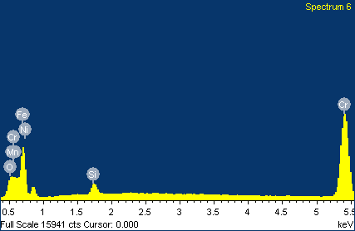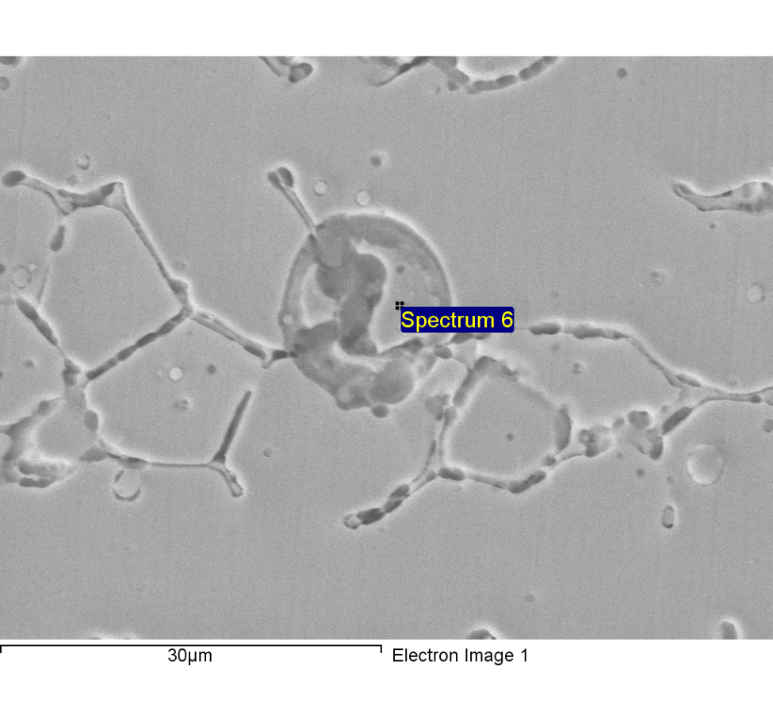

Comment:line1-2-point scan-6

|  |  |  |  |
| --- | --- | --- | --- |
| Element | Weight% | Atomic% |  |
|  |  |  |  |
| C K | 21.50 | 53.28 |  |
| O K | 2.94 | 5.47 |  |
| Si K | 1.01 | 1.07 |  |
| Cr K | 15.91 | 9.11 |  |
| Mn K | 1.31 | 0.71 |  |
| Fe K | 50.28 | 26.79 |  |
| Ni K | 7.04 | 3.57 |  |
|  |  |  |  |
| Totals | 100.00 |  |  |

1/18/2018 3:58:53 PM

Project 2

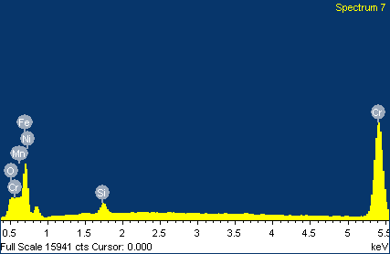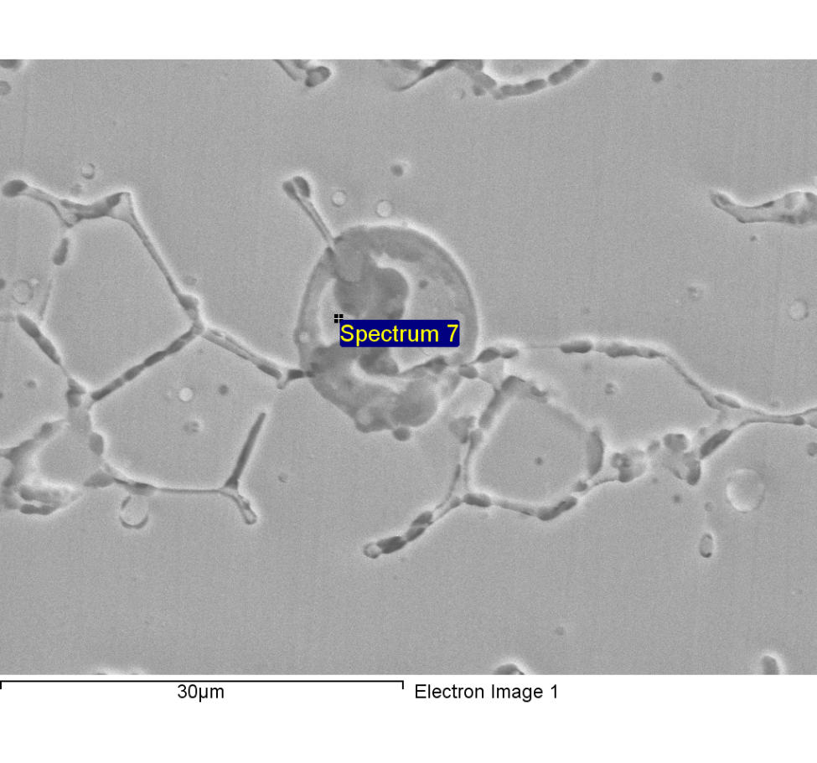

Comment:line1-2-point scan-7

|  |  |  |  |
| --- | --- | --- | --- |
| Element | Weight% | Atomic% |  |
|  |  |  |  |
| C K | 20.13 | 51.28 |  |
| O K | 2.93 | 5.61 |  |
| Si K | 0.88 | 0.96 |  |
| Cr K | 16.25 | 9.56 |  |
| Mn K | 1.29 | 0.72 |  |
| Fe K | 51.25 | 28.08 |  |
| Ni K | 7.27 | 3.79 |  |
|  |  |  |  |
| Totals | 100.00 |  |  |

1/18/2018 3:59:03 PM

Project 2

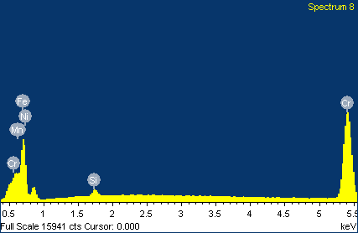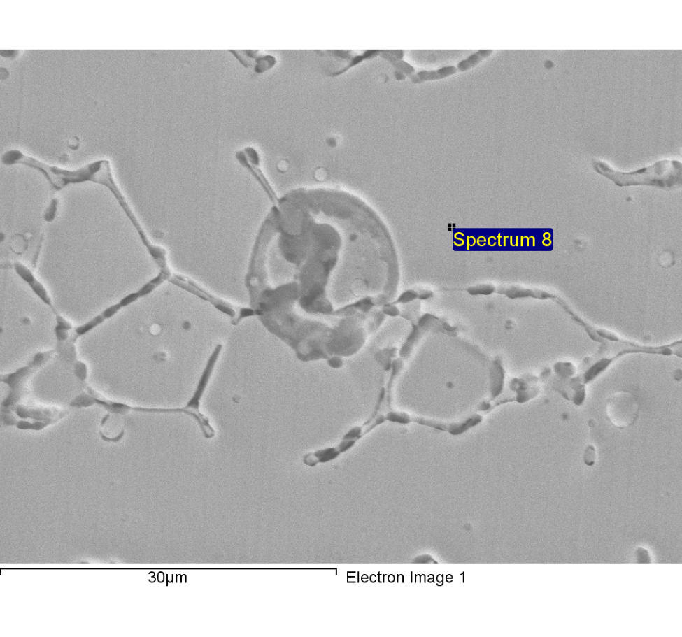

Comment:line1-2-point scan-8

|  |  |  |  |
| --- | --- | --- | --- |
| Element | Weight% | Atomic% |  |
|  |  |  |  |
| C K | 4.17 | 16.56 |  |
| Si K | 0.80 | 1.36 |  |
| Cr K | 19.70 | 18.08 |  |
| Mn K | 1.42 | 1.23 |  |
| Fe K | 64.03 | 54.73 |  |
| Ni K | 9.89 | 8.04 |  |
|  |  |  |  |
| Totals | 100.00 |  |  |

1/18/2018 4:00:46 PM

Project 2

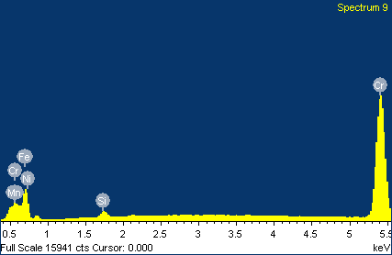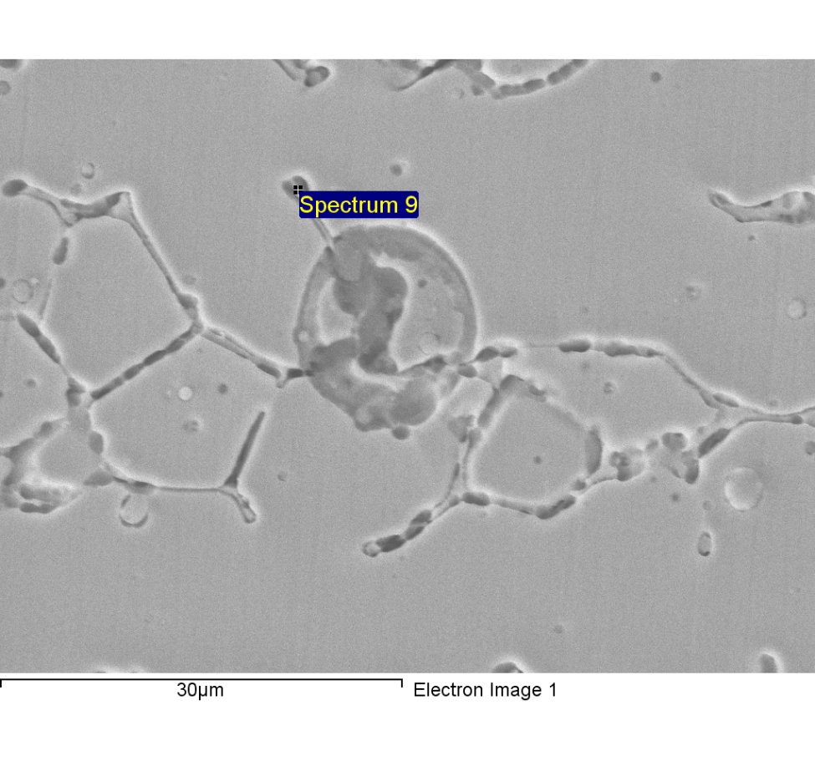

Comment:line1-2-point scan-9

|  |  |  |  |
| --- | --- | --- | --- |
| Element | Weight% | Atomic% |  |
|  |  |  |  |
| C K | 2.13 | 8.97 |  |
| Si K | 0.72 | 1.30 |  |
| Cr K | 26.53 | 25.86 |  |
| Mn K | 1.40 | 1.29 |  |
| Fe K | 64.41 | 58.44 |  |
| Ni K | 4.80 | 4.15 |  |
|  |  |  |  |
| Totals | 100.00 |  |  |

1/18/2018 4:00:55 PM

Project 2

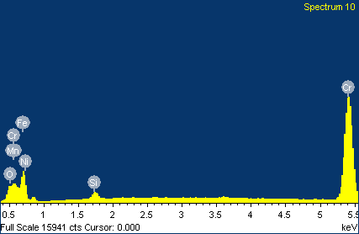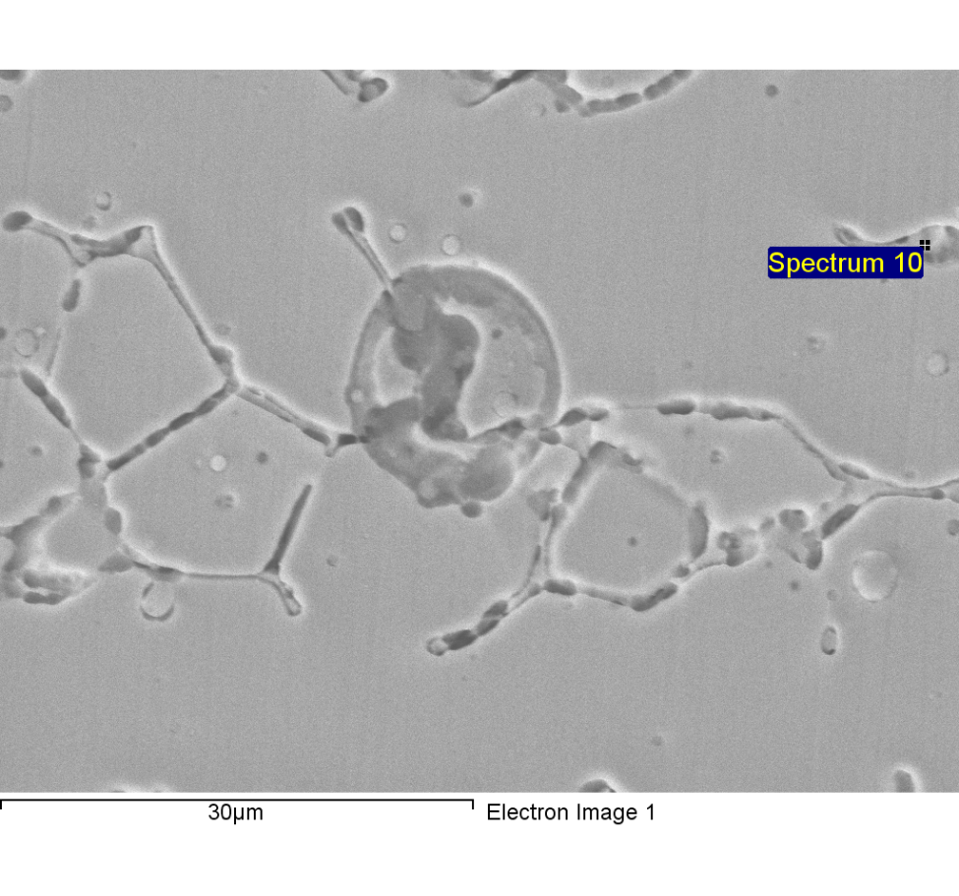

Comment:line1-2-point scan-10

|  |  |  |  |
| --- | --- | --- | --- |
| Element | Weight% | Atomic% |  |
|  |  |  |  |
| C K | 4.66 | 17.64 |  |
| O K | 1.32 | 3.74 |  |
| Si K | 0.83 | 1.34 |  |
| Cr K | 24.85 | 21.75 |  |
| Mn K | 1.42 | 1.18 |  |
| Fe K | 61.77 | 50.34 |  |
| Ni K | 5.16 | 4.00 |  |
|  |  |  |  |
| Totals | 100.00 |  |  |

1/18/2018 4:01:03 PM

Project 2

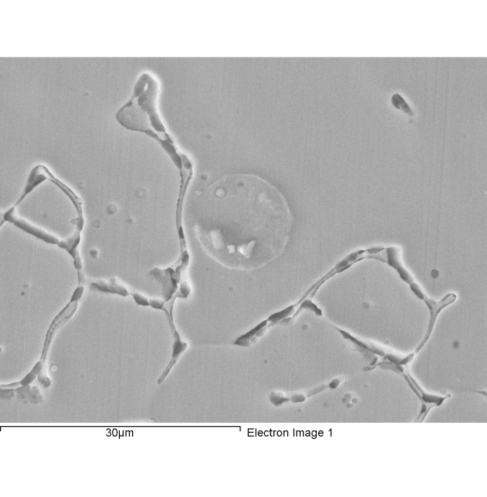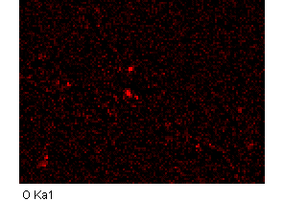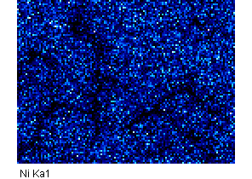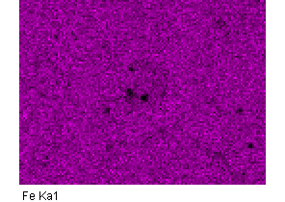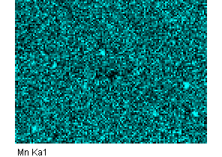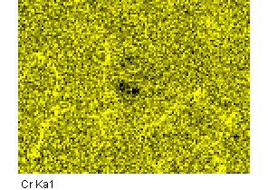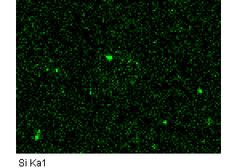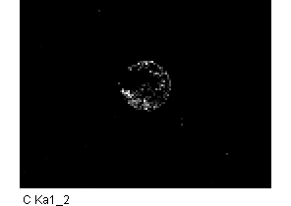

Comment:line1-1重新存

1/18/2018 4:21:47 PM

Project 2

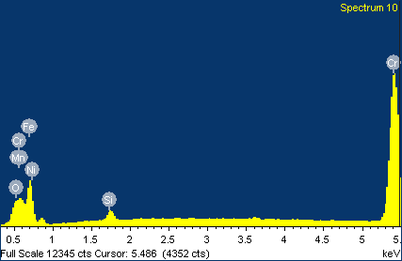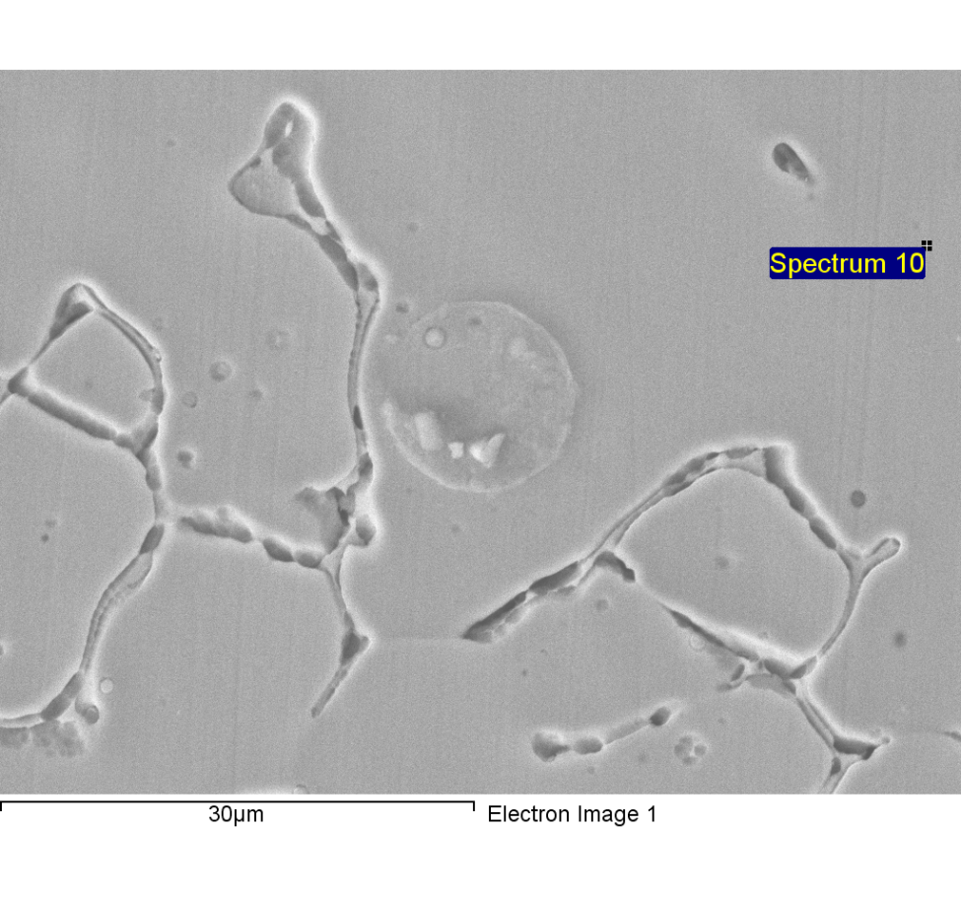

Spectrum processing :

Peaks possibly omitted : 3.612, 10.840, 11.824, 12.800 keV

Processing option : All elements analyzed (Normalised)

Number of iterations = 4

Standard :

C CaCO3 1-Jun-1999 12:00 AM

O SiO2 1-Jun-1999 12:00 AM

Si SiO2 1-Jun-1999 12:00 AM

Cr Cr 1-Jun-1999 12:00 AM

Mn Mn 1-Jun-1999 12:00 AM

Fe Fe 1-Jun-1999 12:00 AM

Ni Ni 1-Jun-1999 12:00 AM

|  |  |  |  |
| --- | --- | --- | --- |
| Element | Weight% | Atomic% |  |
|  |  |  |  |
| C K | 4.66 | 17.64 |  |
| O K | 1.32 | 3.74 |  |
| Si K | 0.83 | 1.34 |  |
| Cr K | 24.85 | 21.75 |  |
| Mn K | 1.42 | 1.18 |  |
| Fe K | 61.77 | 50.34 |  |
| Ni K | 5.16 | 4.00 |  |
|  |  |  |  |
| Totals | 100.00 |  |  |

1/18/2018 4:22:25 PM

Project 2

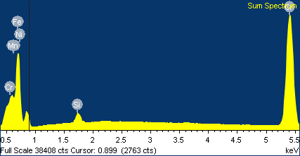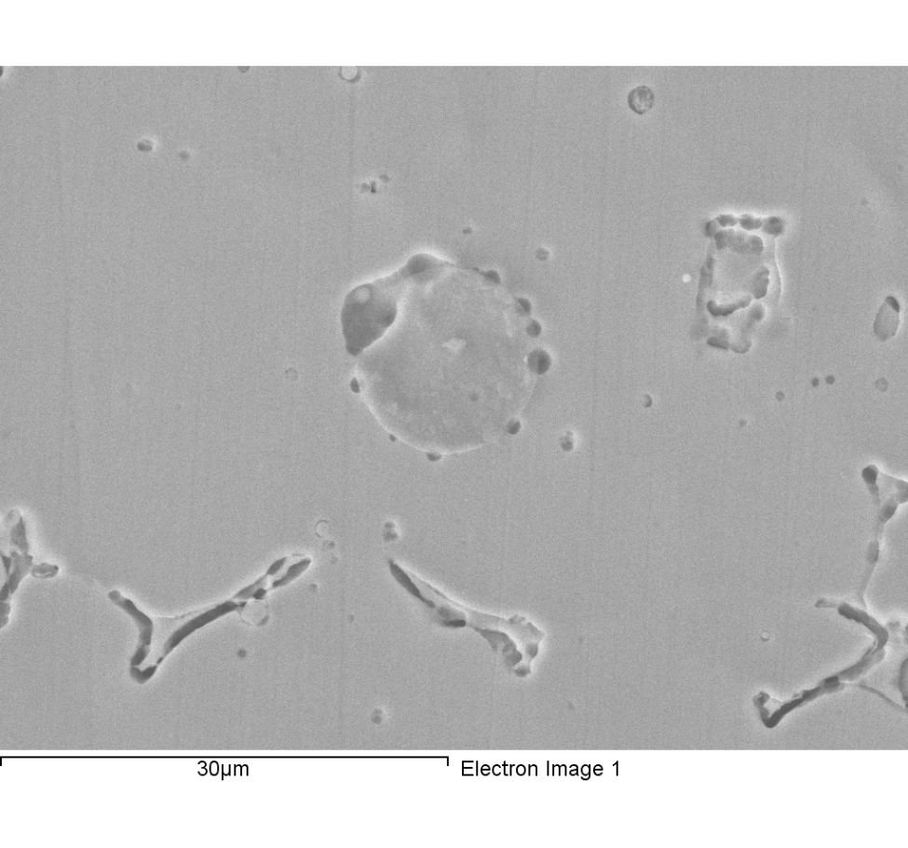

Comment:line1-3mapping-1

|  |  |  |  |
| --- | --- | --- | --- |
| Element | Weight% | Atomic% |  |
|  |  |  |  |
| C K | 5.81 | 21.93 |  |
| Si K | 0.94 | 1.52 |  |
| Cr K | 20.29 | 17.69 |  |
| Mn K | 1.60 | 1.32 |  |
| Fe K | 61.88 | 50.23 |  |
| Ni K | 9.48 | 7.32 |  |
|  |  |  |  |
| Totals | 100.00 |  |  |

1/18/2018 4:35:21 PM

Project 2

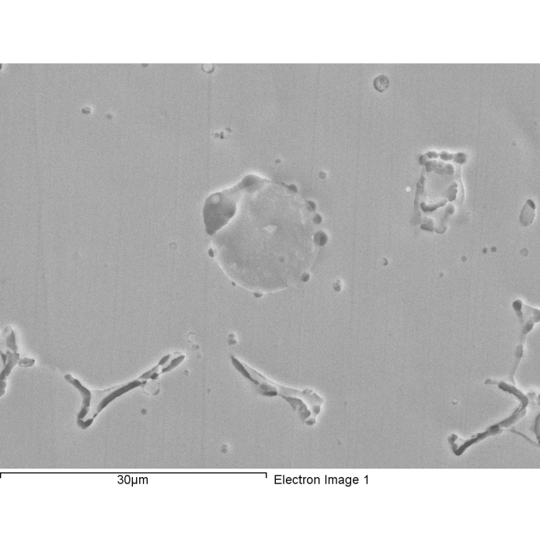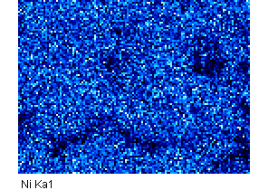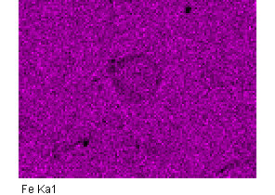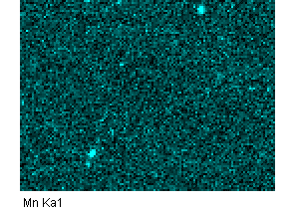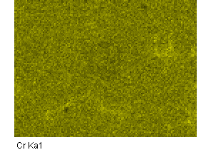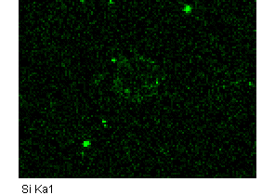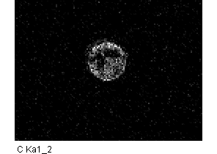

Comment: line 1-3- mapping-1

1/18/2018 4:35:46 PM

Project 2

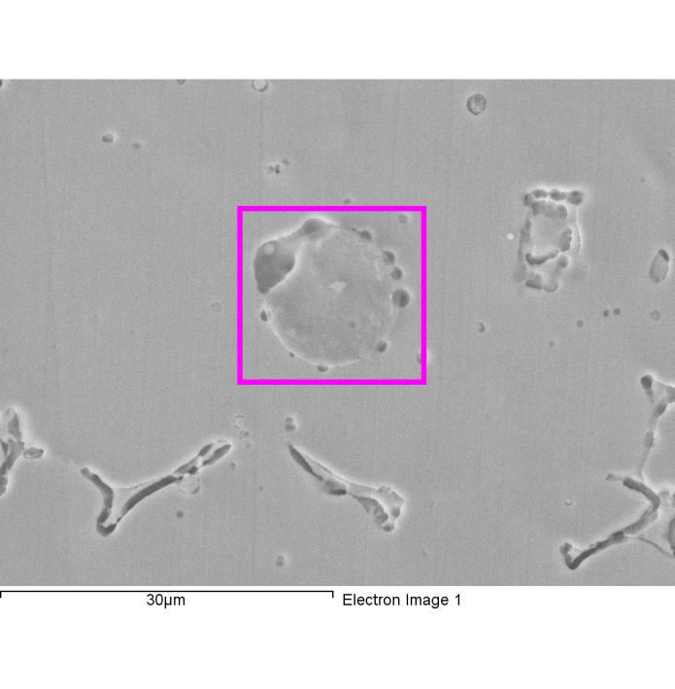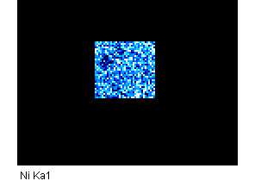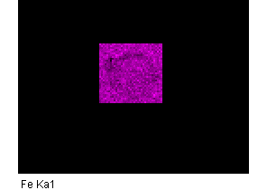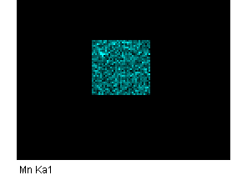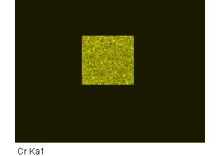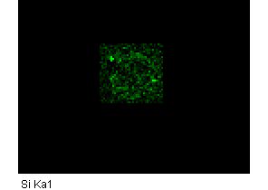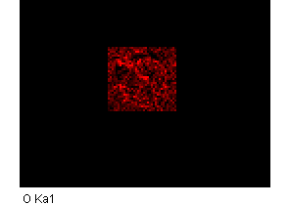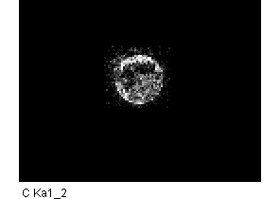

Comment: line1-3mapping-2

1/18/2018 4:39:06 PM

Project 2

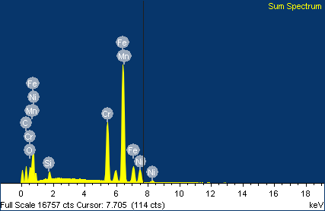

|  |  |  |  |
| --- | --- | --- | --- |
| Element | Weight% | Atomic% |  |
|  |  |  |  |
| C K | 15.80 | 44.15 |  |
| O K | 2.73 | 5.74 |  |
| Si K | 1.08 | 1.28 |  |
| Cr K | 17.01 | 10.98 |  |
| Mn K | 1.41 | 0.86 |  |
| Fe K | 53.36 | 32.06 |  |
| Ni K | 8.61 | 4.92 |  |
|  |  |  |  |
| Totals | 100.00 |  |  |

Comment:line1-3mapping-2

1/18/2018 4:41:05 PM

Project 2

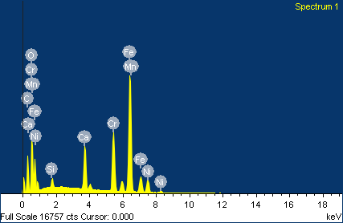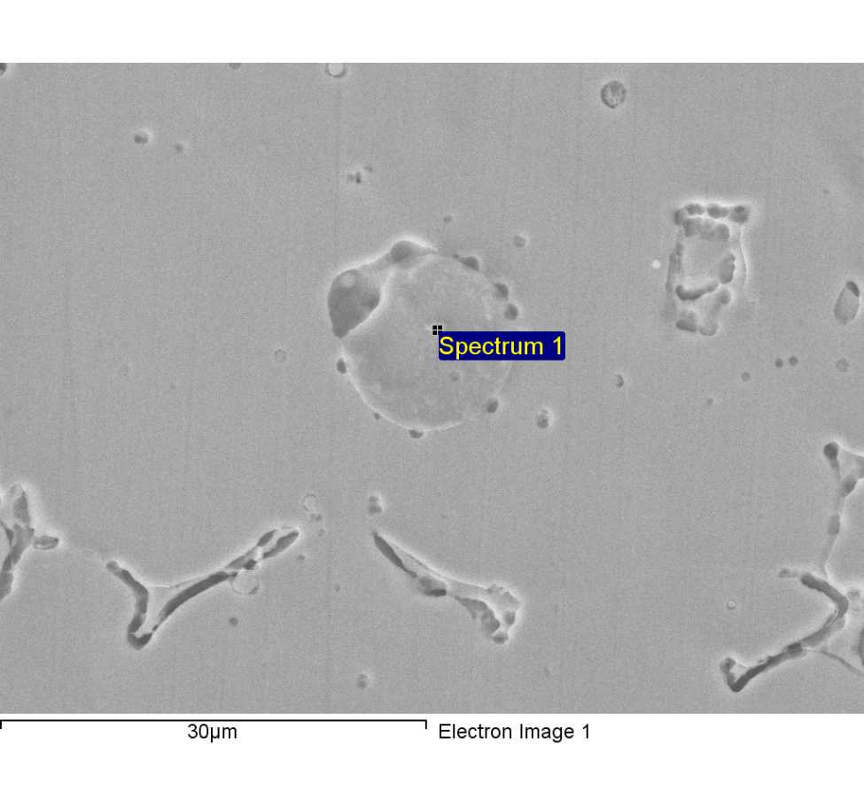

Comment:line1-3-point scan-1

|  |  |  |  |
| --- | --- | --- | --- |
| Element | Weight% | Atomic% |  |
|  |  |  |  |
| C K | 21.21 | 45.10 |  |
| O K | 15.21 | 24.27 |  |
| Si K | 0.80 | 0.73 |  |
| Ca K | 5.01 | 3.19 |  |
| Cr K | 12.65 | 6.21 |  |
| Mn K | 0.97 | 0.45 |  |
| Fe K | 38.06 | 17.40 |  |
| Ni K | 6.08 | 2.64 |  |
|  |  |  |  |
| Totals | 100.00 |  |  |

1/18/2018 4:45:19 PM

Project 2

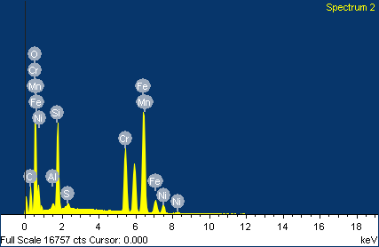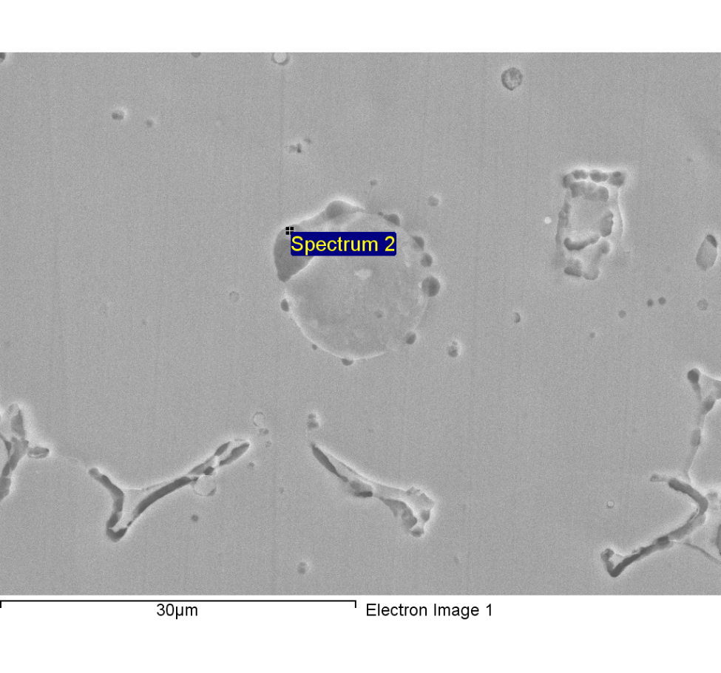

Comment:line1-3-point scan-2

|  |  |  |  |
| --- | --- | --- | --- |
| Element | Weight% | Atomic% |  |
|  |  |  |  |
| C K | 17.14 | 36.11 |  |
| O K | 19.95 | 31.56 |  |
| Al K | 0.42 | 0.39 |  |
| Si K | 6.94 | 6.25 |  |
| S K | 0.32 | 0.25 |  |
| Cr K | 12.21 | 5.94 |  |
| Mn K | 10.60 | 4.88 |  |
| Fe K | 28.85 | 13.07 |  |
| Ni K | 3.58 | 1.54 |  |
|  |  |  |  |
| Totals | 100.00 |  |  |

1/18/2018 4:45:40 PM

Project 2

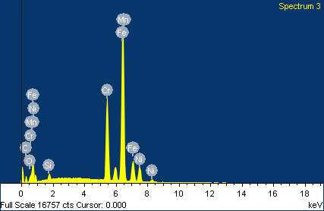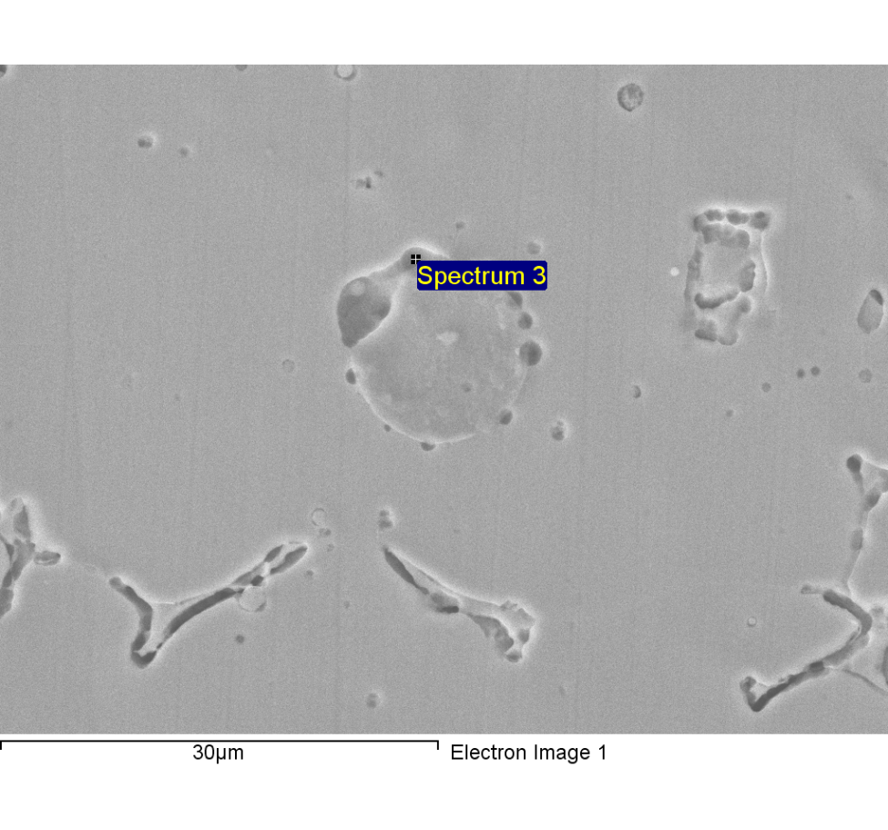

Comment:line1-3-point scan-3

|  |  |  |  |
| --- | --- | --- | --- |
| Element | Weight% | Atomic% |  |
|  |  |  |  |
| C K | 6.79 | 24.54 |  |
| O K | 0.84 | 2.28 |  |
| Si K | 0.70 | 1.09 |  |
| Cr K | 20.09 | 16.78 |  |
| Mn K | 1.48 | 1.17 |  |
| Fe K | 60.82 | 47.29 |  |
| Ni K | 9.29 | 6.87 |  |
|  |  |  |  |
| Totals | 100.00 |  |  |

1/18/2018 4:45:59 PM

Project 2

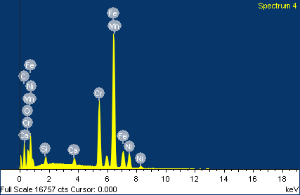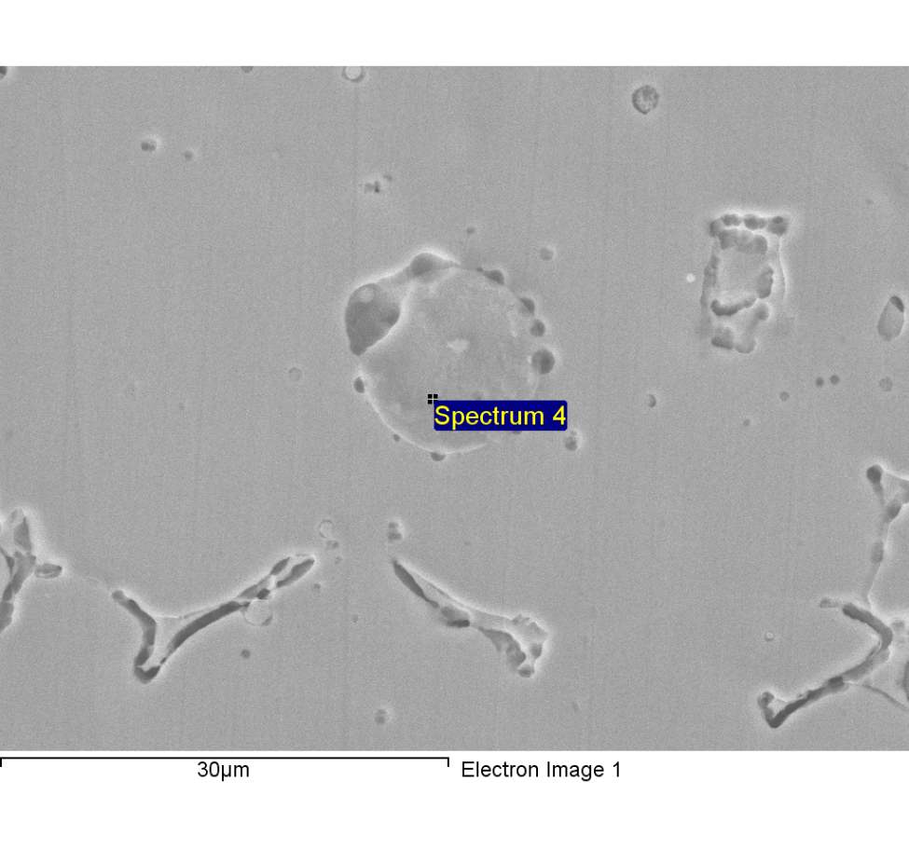

Comment:line1-3-point scan-4

|  |  |  |  |
| --- | --- | --- | --- |
| Element | Weight% | Atomic% |  |
|  |  |  |  |
| C K | 19.52 | 49.36 |  |
| O K | 4.28 | 8.12 |  |
| Si K | 0.84 | 0.90 |  |
| Ca K | 0.90 | 0.68 |  |
| Cr K | 15.54 | 9.08 |  |
| Mn K | 1.24 | 0.69 |  |
| Fe K | 49.82 | 27.10 |  |
| Ni K | 7.87 | 4.07 |  |
|  |  |  |  |
| Totals | 100.00 |  |  |

1/18/2018 4:46:14 PM

Project 2

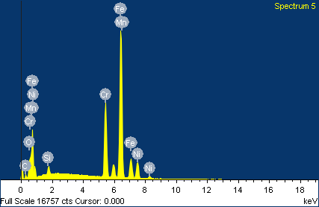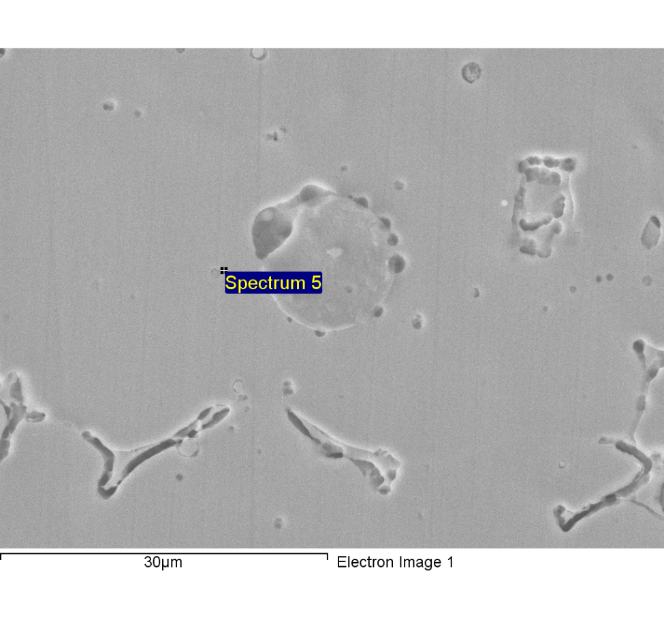

Comment:line1-3-point scan-5

|  |  |  |  |
| --- | --- | --- | --- |
| Element | Weight% | Atomic% |  |
|  |  |  |  |
| C K | 4.43 | 16.77 |  |
| O K | 1.83 | 5.21 |  |
| Si K | 1.17 | 1.90 |  |
| Cr K | 19.40 | 16.97 |  |
| Mn K | 1.68 | 1.39 |  |
| Fe K | 61.07 | 49.71 |  |
| Ni K | 10.41 | 8.06 |  |
|  |  |  |  |
| Totals | 100.00 |  |  |

1/18/2018 4:46:30 PM

Project 2

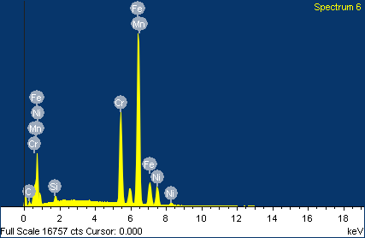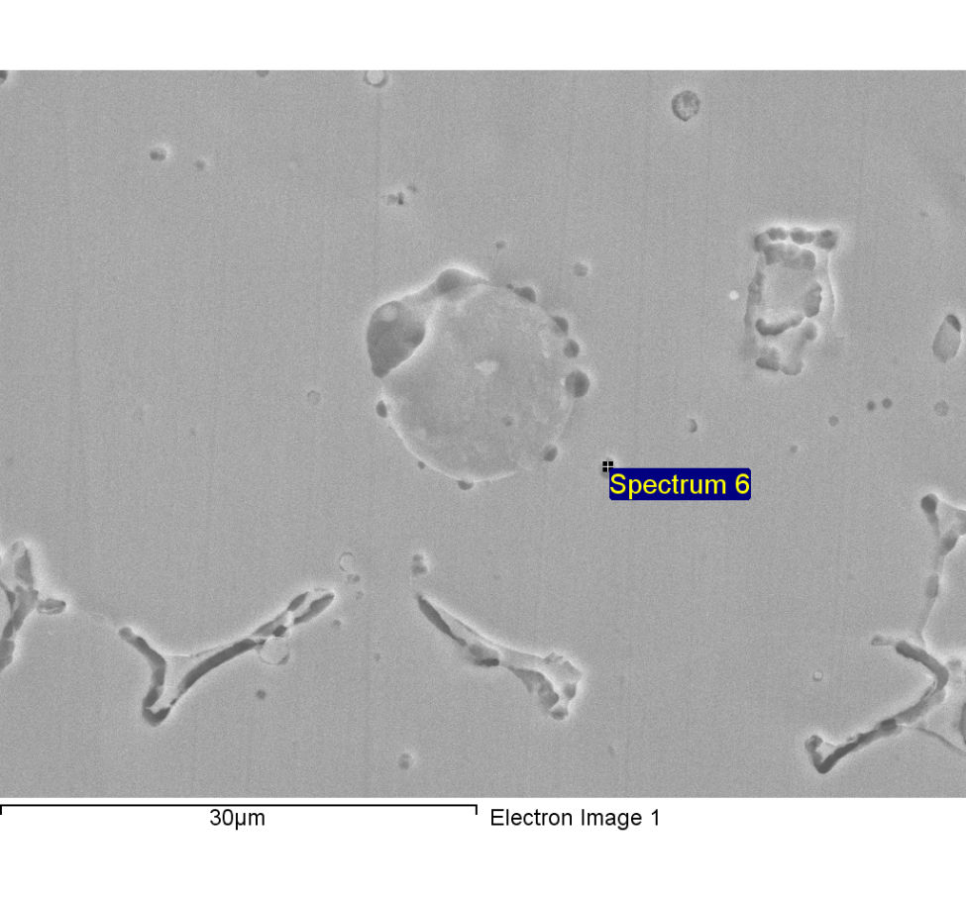

Comment:line1-3-point scan-6

|  |  |  |  |
| --- | --- | --- | --- |
| Element | Weight% | Atomic% |  |
|  |  |  |  |
| C K | 3.99 | 15.95 |  |
| Si K | 0.66 | 1.13 |  |
| Cr K | 20.86 | 19.26 |  |
| Mn K | 1.73 | 1.51 |  |
| Fe K | 62.72 | 53.94 |  |
| Ni K | 10.05 | 8.22 |  |
|  |  |  |  |
| Totals | 100.00 |  |  |

1/18/2018 4:46:51 PM

Project 2

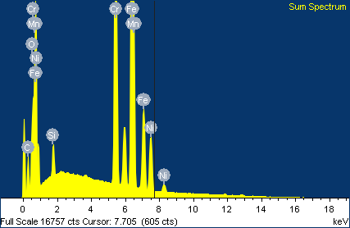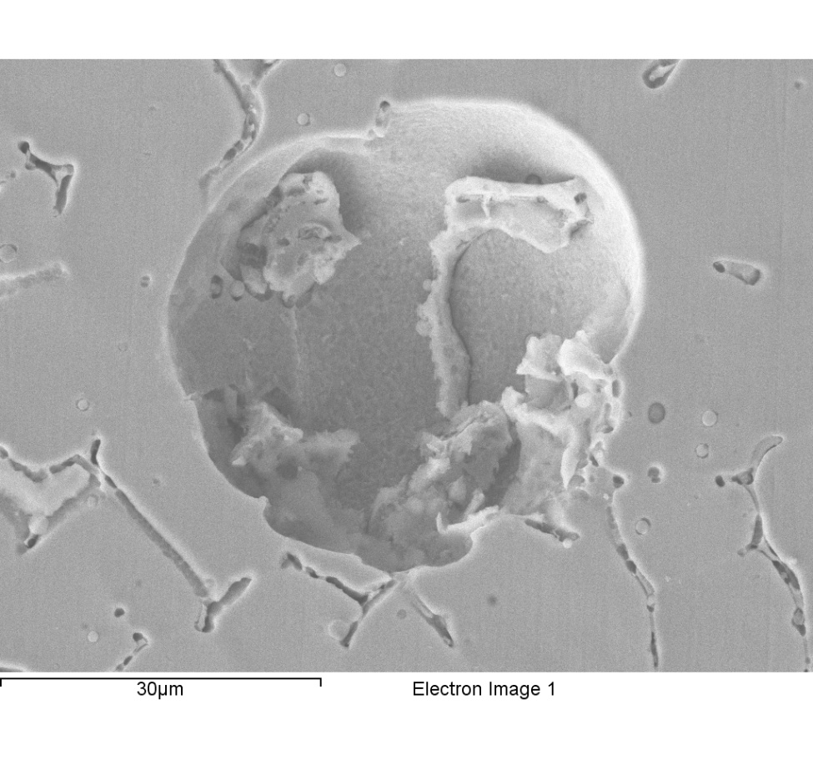

Comment:line1-4-mapping-1

|  |  |  |  |
| --- | --- | --- | --- |
| Element | Weight% | Atomic% |  |
|  |  |  |  |
| C K | 7.68 | 26.62 |  |
| O K | 1.59 | 4.14 |  |
| Si K | 0.99 | 1.47 |  |
| Cr K | 20.48 | 16.40 |  |
| Mn K | 1.71 | 1.29 |  |
| Fe K | 59.33 | 44.24 |  |
| Ni K | 8.23 | 5.84 |  |
|  |  |  |  |
| Totals | 100.00 |  |  |

1/18/2018 4:53:48 PM

Project 2

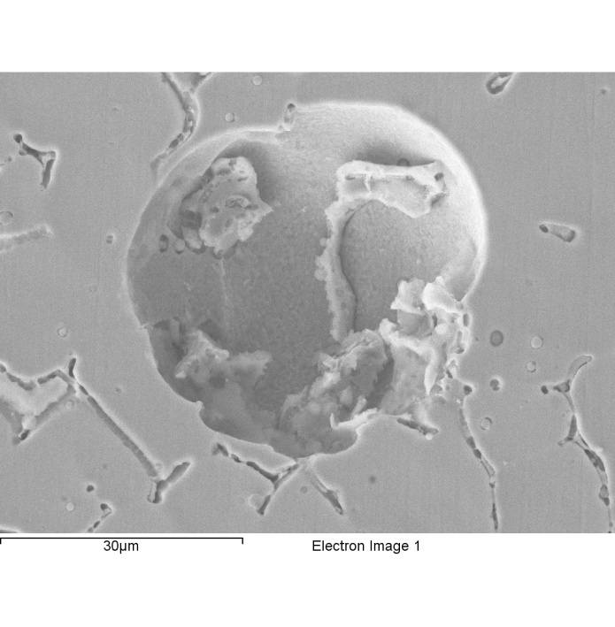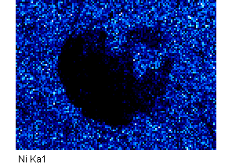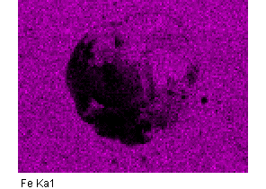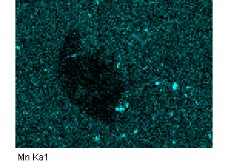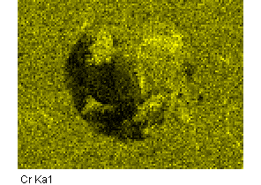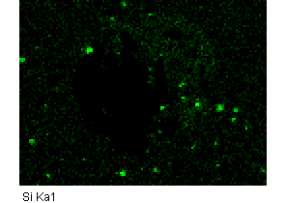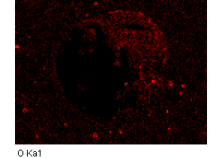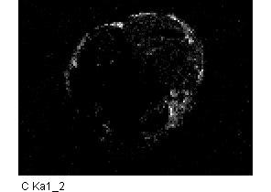

Comment:1-4-mapping-1

1/18/2018 4:54:53 PM

Project 2

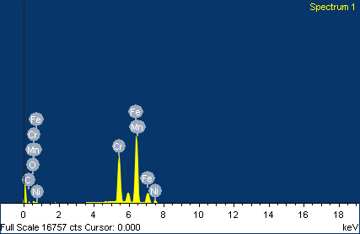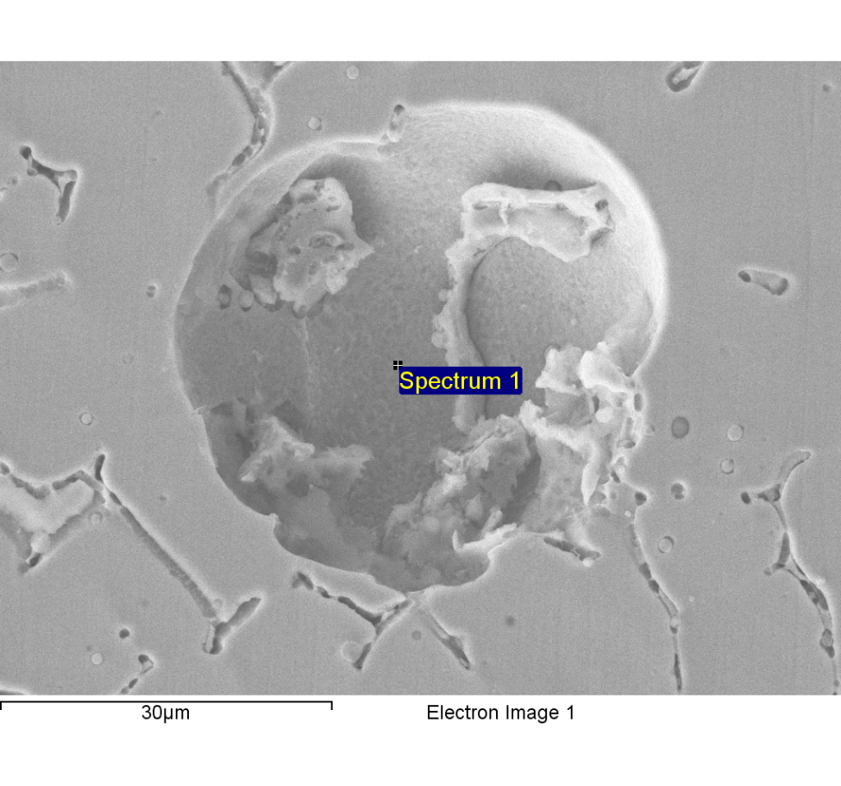

Comment:line1-4-point scan-1

|  |  |  |  |
| --- | --- | --- | --- |
| Element | Weight% | Atomic% |  |
|  |  |  |  |
| C K | 3.40 | 13.63 |  |
| O K | 0.62 | 1.87 |  |
| Si K | 0.24 | 0.41 |  |
| Cr K | 26.60 | 24.62 |  |
| Mn K | 2.96 | 2.59 |  |
| Fe K | 62.40 | 53.78 |  |
| Ni K | 3.77 | 3.09 |  |
|  |  |  |  |
| Totals | 100.00 |  |  |

1/18/2018 4:59:18 PM

Project 2

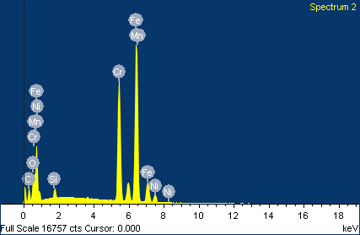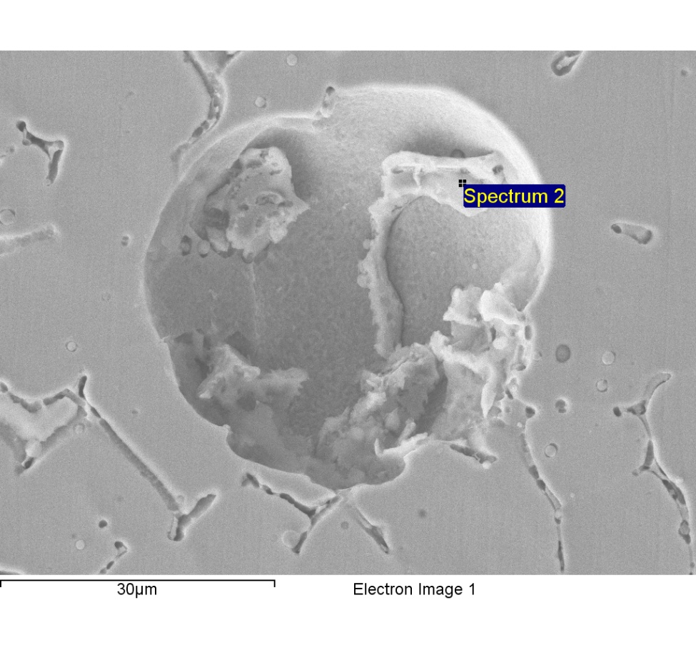

Comment:line1-4-point scan-2

|  |  |  |  |
| --- | --- | --- | --- |
| Element | Weight% | Atomic% |  |
|  |  |  |  |
| C K | 10.29 | 32.84 |  |
| O K | 2.18 | 5.23 |  |
| Si K | 0.96 | 1.31 |  |
| Cr K | 26.32 | 19.40 |  |
| Mn K | 1.26 | 0.88 |  |
| Fe K | 54.96 | 37.72 |  |
| Ni K | 4.03 | 2.63 |  |
|  |  |  |  |
| Totals | 100.00 |  |  |

1/18/2018 4:59:33 PM

Project 2

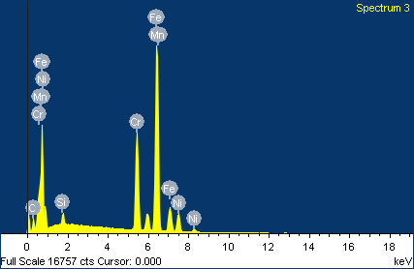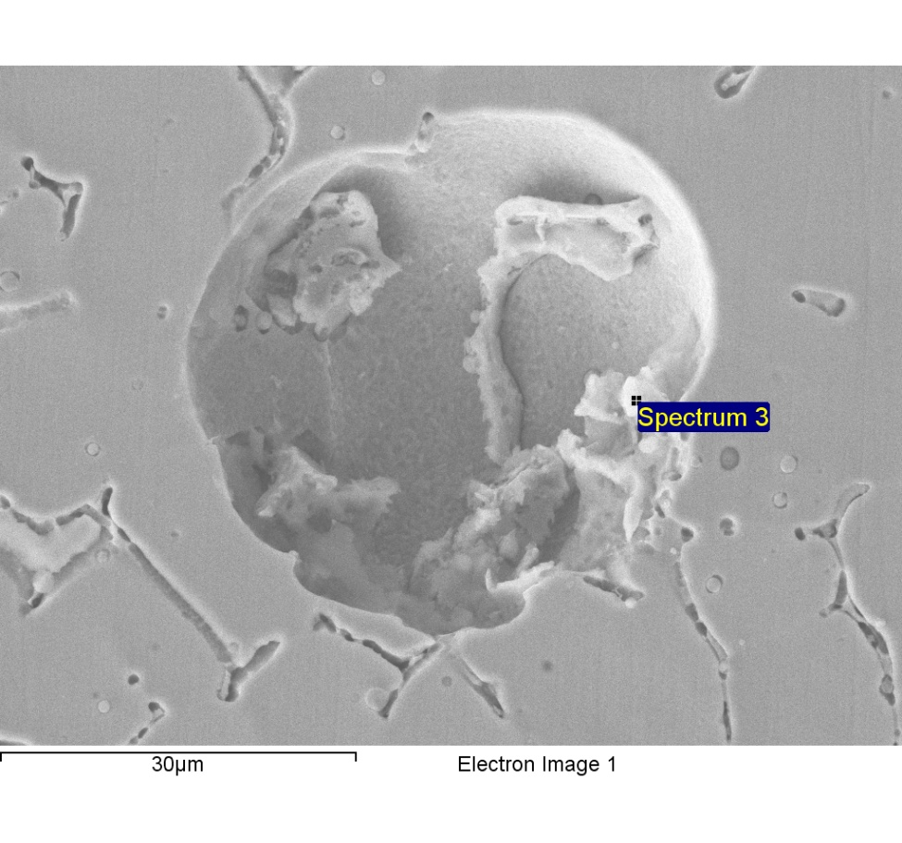

Comment:line1-4-point scan-3

|  |  |  |  |
| --- | --- | --- | --- |
| Element | Weight% | Atomic% |  |
|  |  |  |  |
| C K | 9.24 | 31.59 |  |
| Si K | 1.19 | 1.75 |  |
| Cr K | 19.69 | 15.56 |  |
| Mn K | 1.37 | 1.03 |  |
| Fe K | 59.82 | 44.00 |  |
| Ni K | 8.68 | 6.08 |  |
|  |  |  |  |
| Totals | 100.00 |  |  |

1/18/2018 4:59:46 PM

Project 2

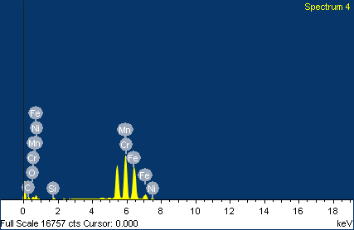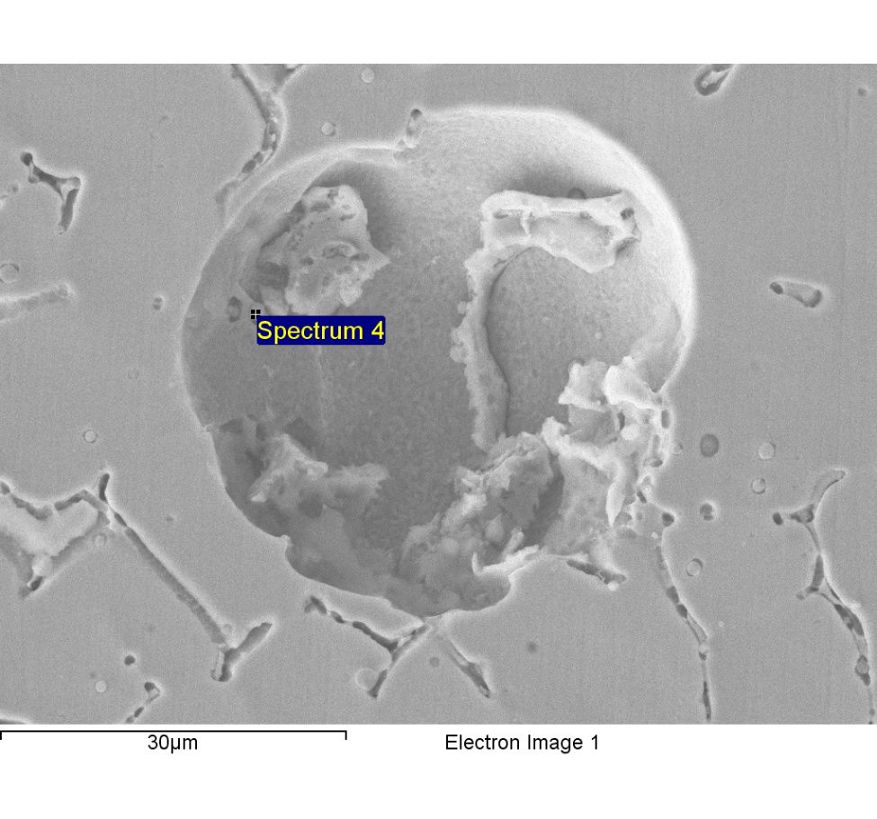

Comment:line1-4-point scan-4

|  |  |  |  |
| --- | --- | --- | --- |
| Element | Weight% | Atomic% |  |
|  |  |  |  |
| C K | 6.81 | 24.31 |  |
| O K | 1.08 | 2.88 |  |
| Si K | 0.62 | 0.94 |  |
| Cr K | 22.97 | 18.93 |  |
| Mn K | 34.40 | 26.83 |  |
| Fe K | 31.98 | 24.54 |  |
| Ni K | 2.15 | 1.57 |  |
|  |  |  |  |
| Totals | 100.00 |  |  |

1/18/2018 4:59:59 PM

Project 2

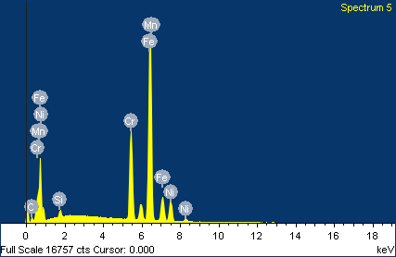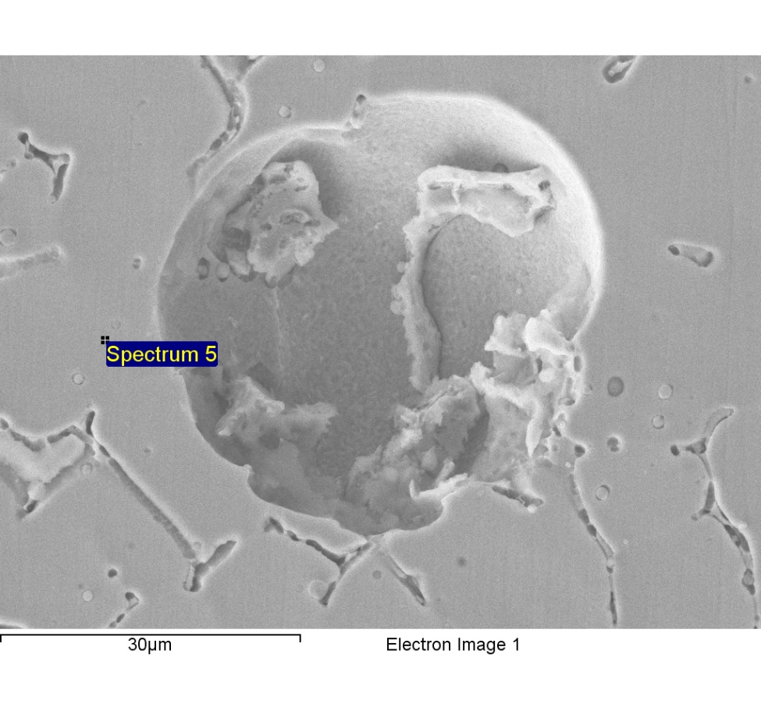

Comment:line1-4-point scan-5

|  |  |  |  |
| --- | --- | --- | --- |
| Element | Weight% | Atomic% |  |
|  |  |  |  |
| C K | 3.97 | 15.88 |  |
| Si K | 0.78 | 1.34 |  |
| Cr K | 19.33 | 17.87 |  |
| Mn K | 1.65 | 1.44 |  |
| Fe K | 63.98 | 55.06 |  |
| Ni K | 10.29 | 8.42 |  |
|  |  |  |  |
| Totals | 100.00 |  |  |

1/18/2018 5:00:13 PM

Project 2

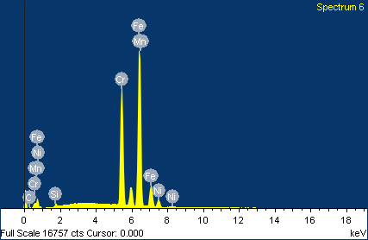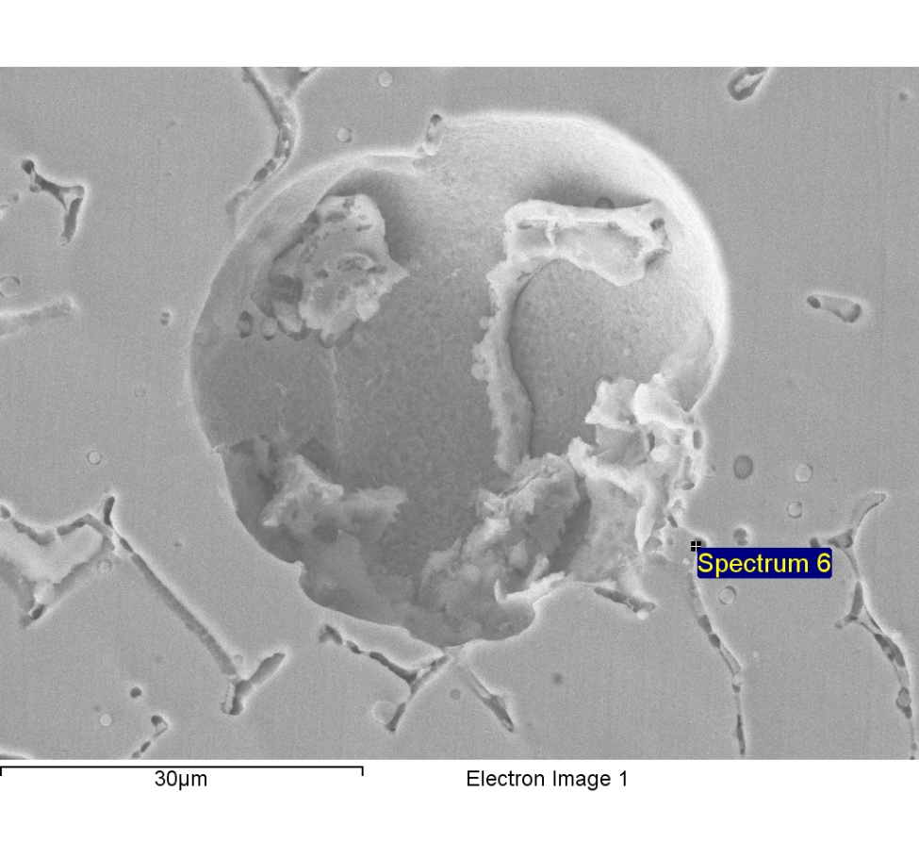

Comment:line1-4-point scan-6

|  |  |  |  |
| --- | --- | --- | --- |
| Element | Weight% | Atomic% |  |
|  |  |  |  |
| C K | 0.99 | 4.36 |  |
| Si K | 0.37 | 0.70 |  |
| Cr K | 29.32 | 29.72 |  |
| Mn K | 1.56 | 1.50 |  |
| Fe K | 63.47 | 59.88 |  |
| Ni K | 4.29 | 3.85 |  |
|  |  |  |  |
| Totals | 100.00 |  |  |

1/18/2018 5:00:26 PM

Project 2

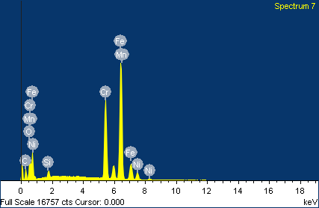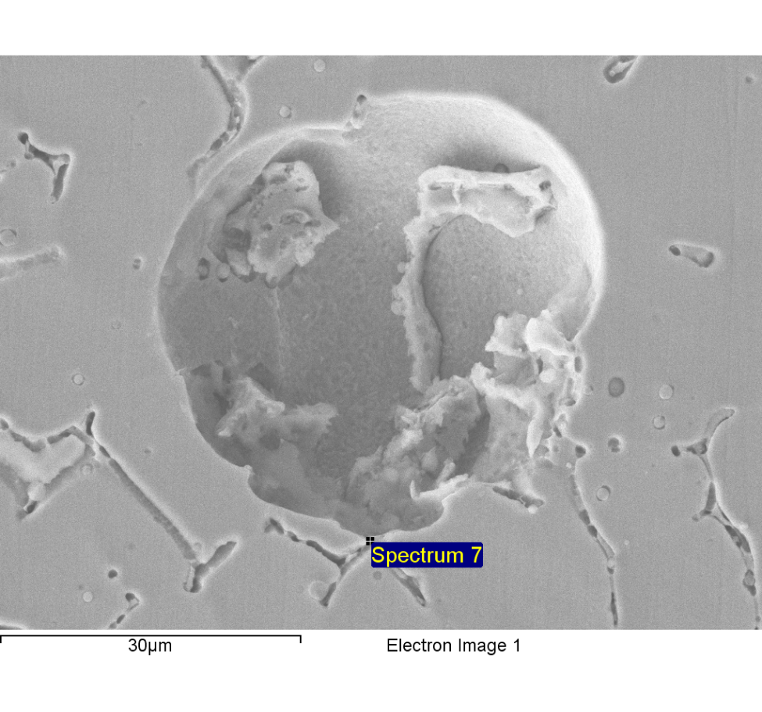-

Comment:line1-4-point scan-7

|  |  |  |  |
| --- | --- | --- | --- |
| Element | Weight% | Atomic% |  |
|  |  |  |  |
| C K | 11.12 | 34.39 |  |
| O K | 2.98 | 6.91 |  |
| Si K | 0.89 | 1.18 |  |
| Cr K | 23.22 | 16.58 |  |
| Mn K | 1.53 | 1.03 |  |
| Fe K | 55.59 | 36.96 |  |
| Ni K | 4.67 | 2.95 |  |
|  |  |  |  |
| Totals | 100.00 |  |  |

1/18/2018 5:00:41 PM

Project 2

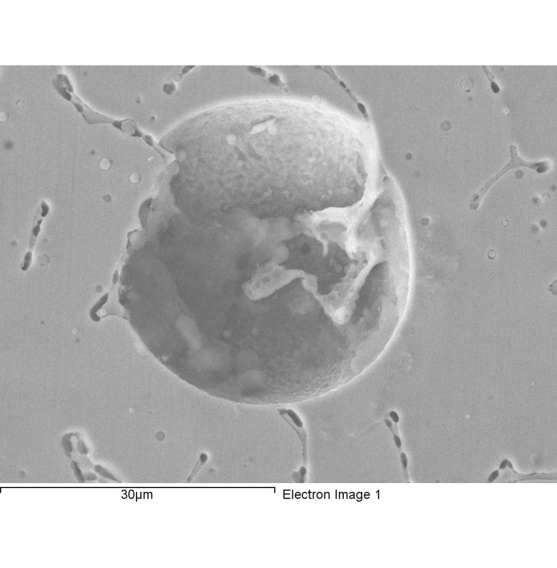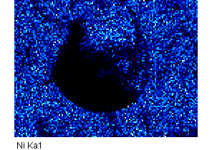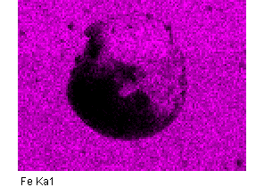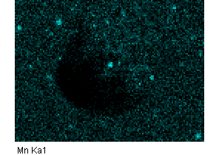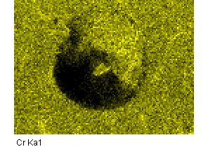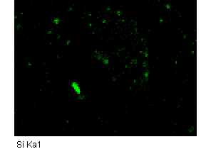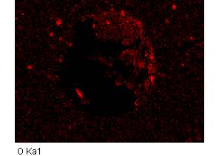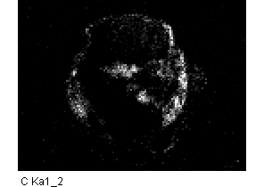

Comment:1-5-mapping-1

1/18/2018 5:05:24 PM

Project 2

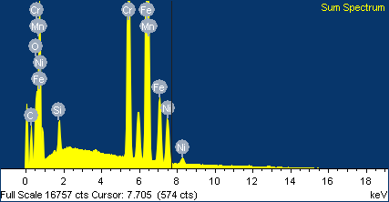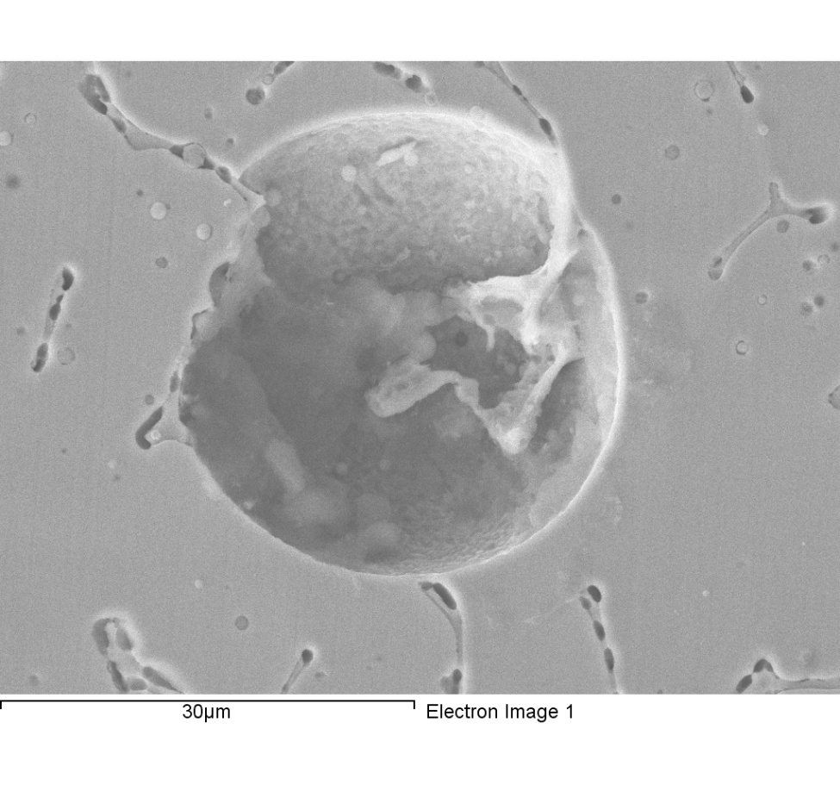

|  |  |  |  |
| --- | --- | --- | --- |
| Element | Weight% | Atomic% |  |
|  |  |  |  |
| C K | 9.98 | 32.35 |  |
| O K | 1.94 | 4.73 |  |
| Si K | 1.15 | 1.60 |  |
| Cr K | 19.35 | 14.49 |  |
| Mn K | 1.72 | 1.22 |  |
| Fe K | 57.78 | 40.27 |  |
| Ni K | 8.06 | 5.34 |  |
|  |  |  |  |
| Totals | 100.00 |  |  |

Comment:1-5-mapping-1

1/18/2018 5:05:52 PM

Project 2

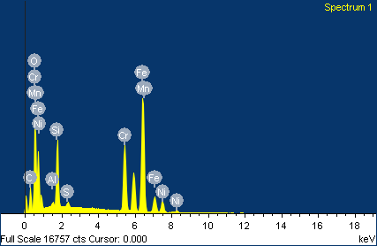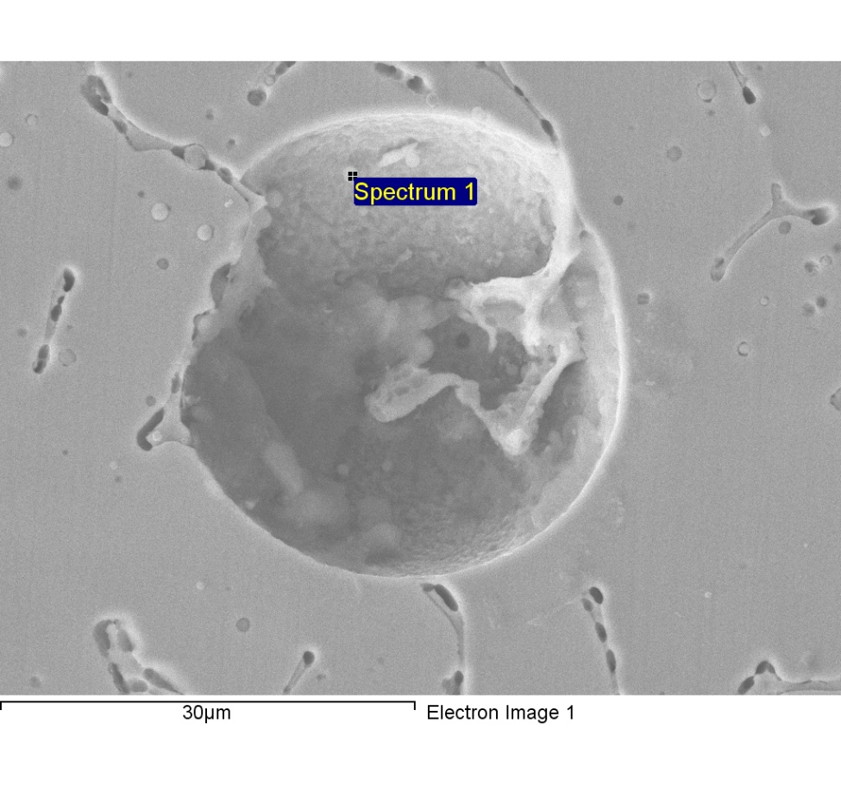

Comment:line1-5-point scan-1

|  |  |  |  |
| --- | --- | --- | --- |
| Element | Weight% | Atomic% |  |
|  |  |  |  |
| C K | 16.01 | 35.87 |  |
| O K | 16.79 | 28.24 |  |
| Al K | 0.37 | 0.37 |  |
| Si K | 5.79 | 5.55 |  |
| S K | 0.35 | 0.30 |  |
| Cr K | 13.24 | 6.85 |  |
| Mn K | 8.29 | 4.06 |  |
| Fe K | 34.20 | 16.48 |  |
| Ni K | 4.97 | 2.28 |  |
|  |  |  |  |
| Totals | 100.00 |  |  |

1/18/2018 5:10:18 PM

Project 2

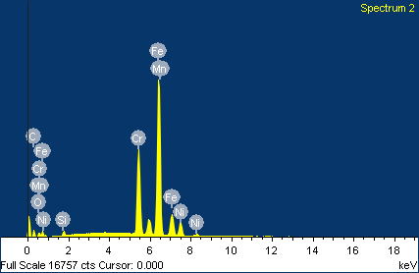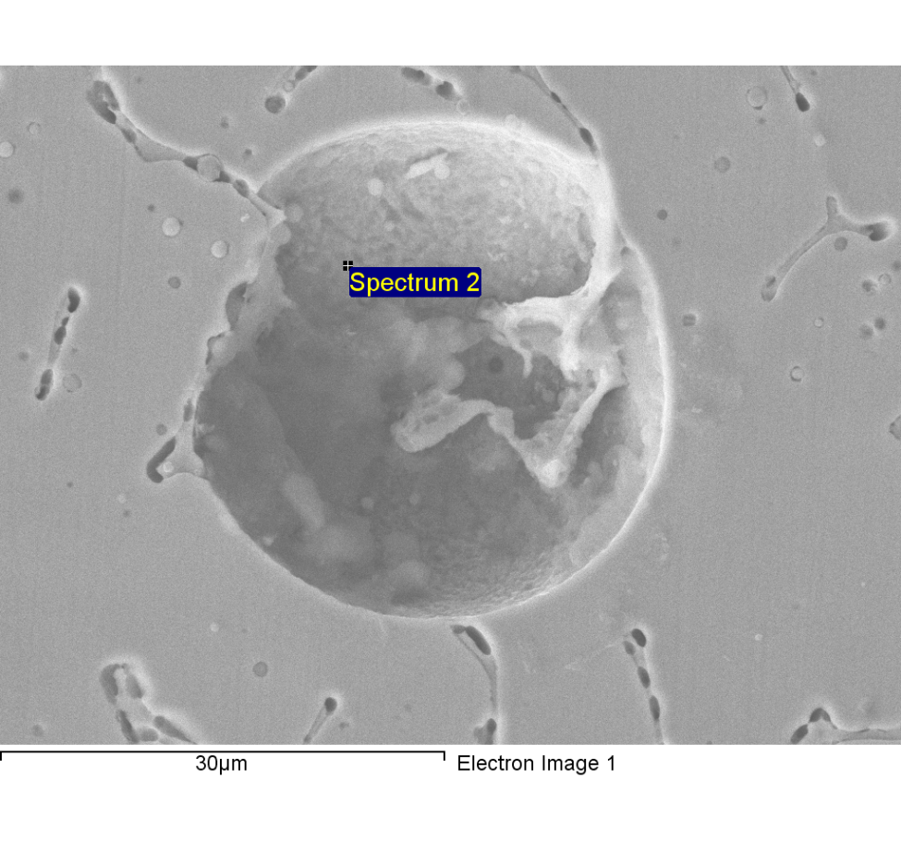

Comment:line1-5-point scan-2

|  |  |  |  |
| --- | --- | --- | --- |
| Element | Weight% | Atomic% |  |
|  |  |  |  |
| C K | 6.70 | 24.32 |  |
| O K | 0.79 | 2.15 |  |
| Si K | 0.54 | 0.84 |  |
| Cr K | 20.64 | 17.30 |  |
| Mn K | 1.78 | 1.41 |  |
| Fe K | 61.38 | 47.91 |  |
| Ni K | 8.17 | 6.06 |  |
|  |  |  |  |
| Totals | 100.00 |  |  |

1/18/2018 5:10:34 PM

Project 2

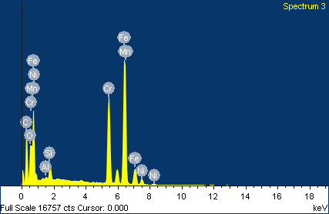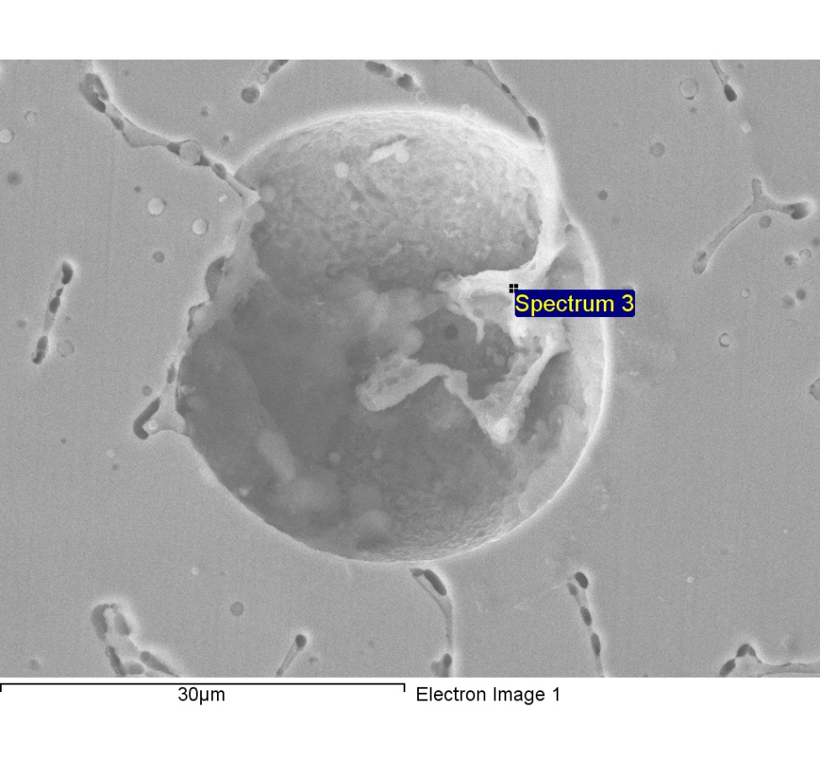

Comment:line1-5-point scan-3

|  |  |  |  |
| --- | --- | --- | --- |
| Element | Weight% | Atomic% |  |
|  |  |  |  |
| C K | 30.38 | 62.25 |  |
| O K | 5.31 | 8.16 |  |
| Al K | 0.19 | 0.17 |  |
| Si K | 1.42 | 1.24 |  |
| Cr K | 17.99 | 8.52 |  |
| Mn K | 1.05 | 0.47 |  |
| Fe K | 41.04 | 18.09 |  |
| Ni K | 2.62 | 1.10 |  |
|  |  |  |  |
| Totals | 100.00 |  |  |

1/18/2018 5:10:53 PM

Project 2

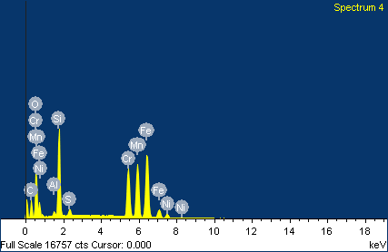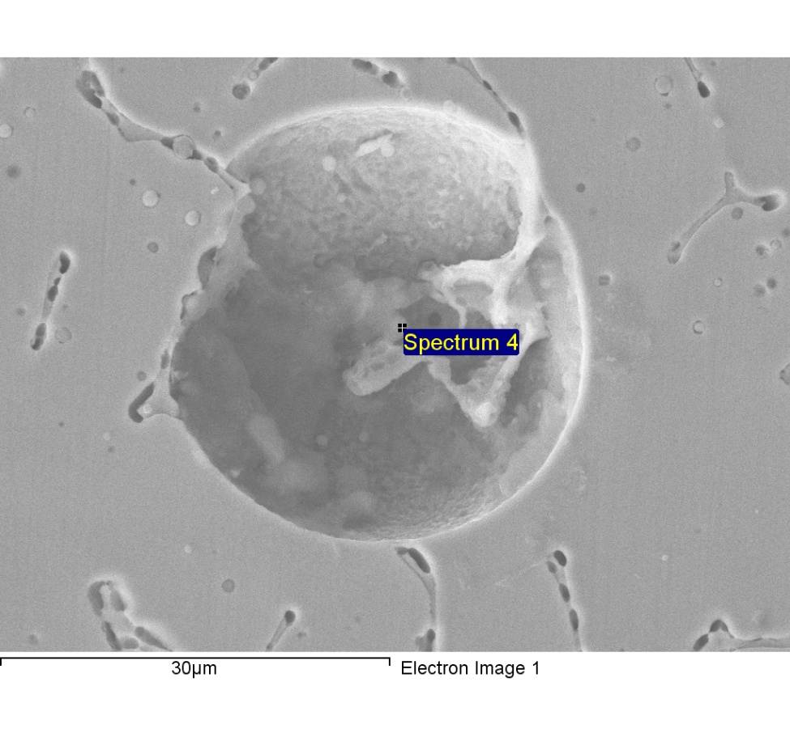

Comment:line1-5-point scan-4

|  |  |  |  |
| --- | --- | --- | --- |
| Element | Weight% | Atomic% |  |
|  |  |  |  |
| C K | 17.63 | 38.94 |  |
| O K | 13.82 | 22.91 |  |
| Al K | 0.45 | 0.44 |  |
| Si K | 9.75 | 9.21 |  |
| S K | 0.70 | 0.58 |  |
| Cr K | 13.42 | 6.85 |  |
| Mn K | 16.74 | 8.08 |  |
| Fe K | 25.10 | 11.92 |  |
| Ni K | 2.39 | 1.08 |  |
|  |  |  |  |
| Totals | 100.00 |  |  |

1/18/2018 5:11:10 PM

Project 2

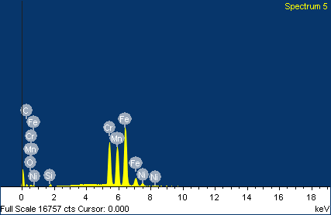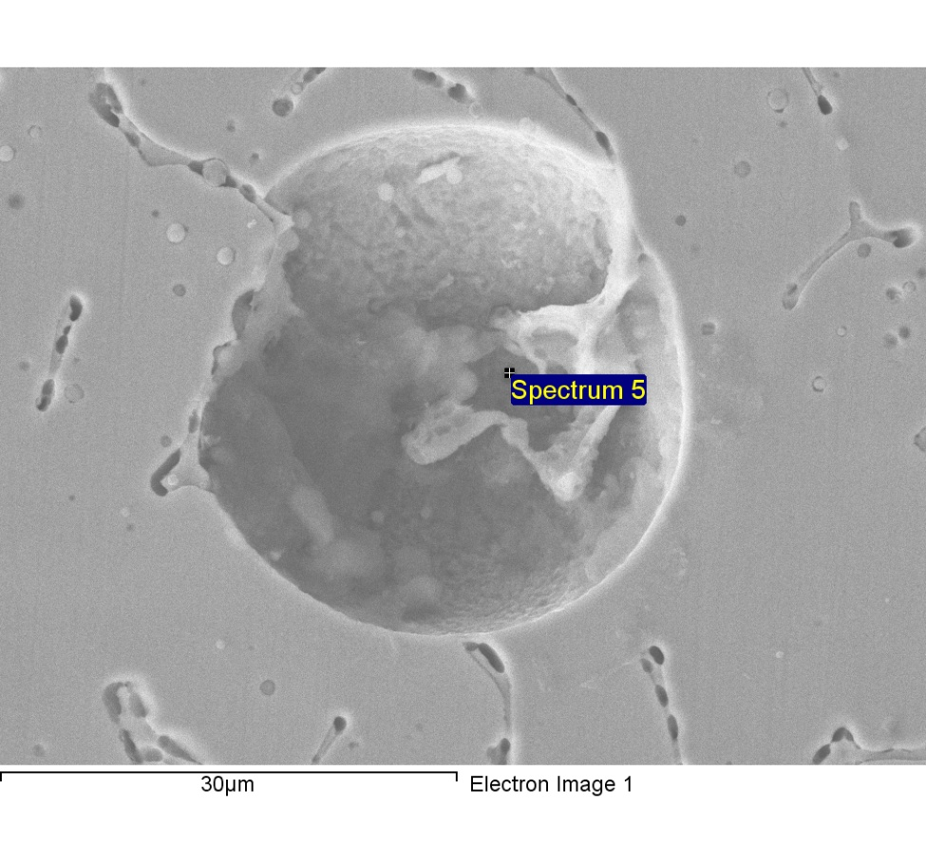

Comment:line1-5-point scan-5

|  |  |  |  |
| --- | --- | --- | --- |
| Element | Weight% | Atomic% |  |
|  |  |  |  |
| C K | 5.11 | 19.45 |  |
| O K | 0.50 | 1.42 |  |
| Si K | 0.51 | 0.83 |  |
| Cr K | 21.96 | 19.30 |  |
| Mn K | 22.97 | 19.11 |  |
| Fe K | 44.96 | 36.78 |  |
| Ni K | 3.99 | 3.11 |  |
|  |  |  |  |
| Totals | 100.00 |  |  |

1/18/2018 5:11:29 PM

Project 2

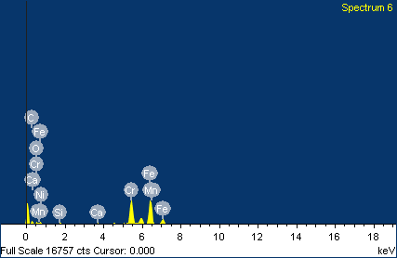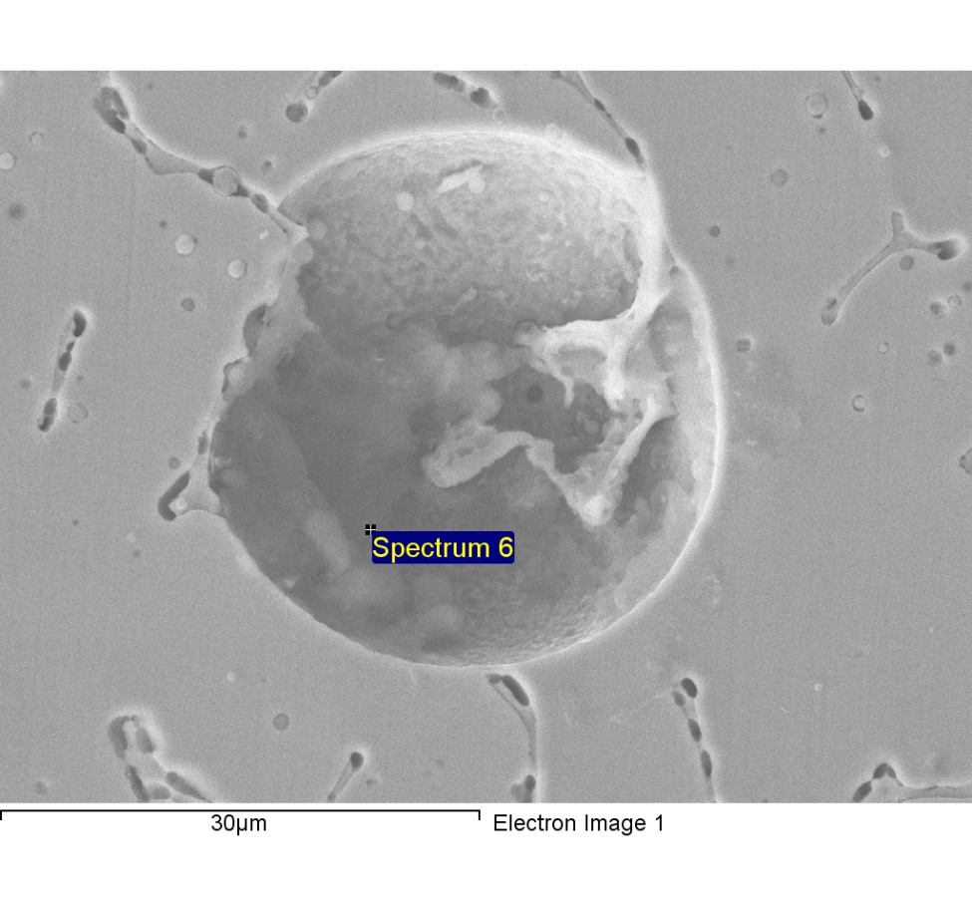

Comment:line1-5-point scan-6

|  |  |  |  |
| --- | --- | --- | --- |
| Element | Weight% | Atomic% |  |
|  |  |  |  |
| C K | 14.68 | 42.40 |  |
| O K | 1.75 | 3.79 |  |
| Si K | 0.88 | 1.09 |  |
| Ca K | 0.28 | 0.24 |  |
| Cr K | 28.20 | 18.82 |  |
| Mn K | 4.61 | 2.91 |  |
| Fe K | 48.02 | 29.83 |  |
| Ni K | 1.58 | 0.93 |  |
|  |  |  |  |
| Totals | 100.00 |  |  |

1/18/2018 5:11:49 PM

Project 2

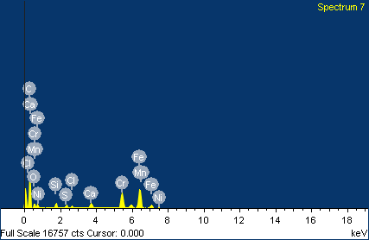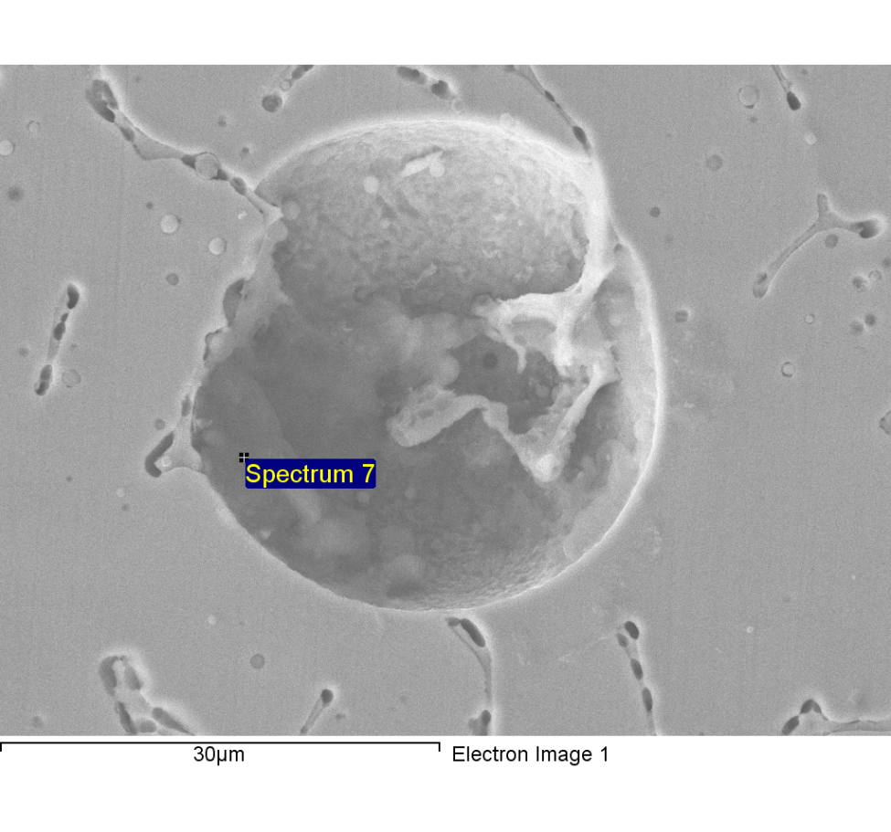

Comment:line1-5-point scan-7

|  |  |  |  |
| --- | --- | --- | --- |
| Element | Weight% | Atomic% |  |
|  |  |  |  |
| C K | 54.91 | 80.44 |  |
| O K | 5.43 | 5.97 |  |
| Si K | 1.13 | 0.71 |  |
| S K | 0.79 | 0.43 |  |
| Cl K | 0.58 | 0.29 |  |
| Ca K | 1.64 | 0.72 |  |
| Cr K | 11.01 | 3.73 |  |
| Mn K | 1.32 | 0.42 |  |
| Fe K | 22.11 | 6.97 |  |
| Ni K | 1.07 | 0.32 |  |
|  |  |  |  |
| Totals | 100.00 |  |  |

1/18/2018 5:12:06 PM

Project 2

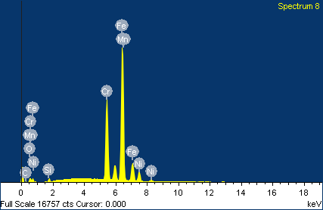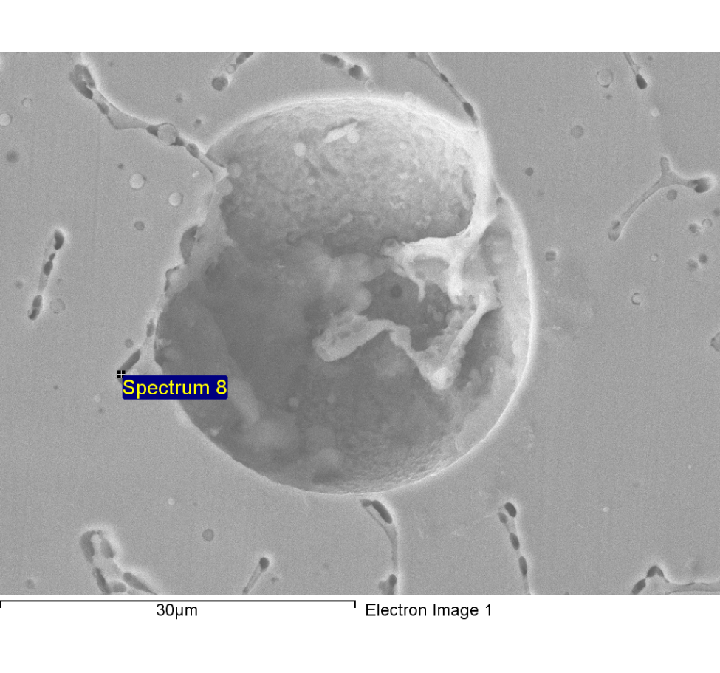

Comment:line1-5-point scan-8

|  |  |  |  |
| --- | --- | --- | --- |
| Element | Weight% | Atomic% |  |
|  |  |  |  |
| C K | 0.66 | 2.88 |  |
| O K | 0.66 | 2.19 |  |
| Si K | 0.47 | 0.88 |  |
| Cr K | 24.33 | 24.64 |  |
| Mn K | 2.01 | 1.93 |  |
| Fe K | 65.19 | 61.49 |  |
| Ni K | 6.68 | 5.99 |  |
|  |  |  |  |
| Totals | 100.00 |  |  |

1/18/2018 5:12:23 PM

Project 2

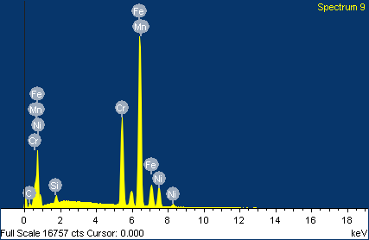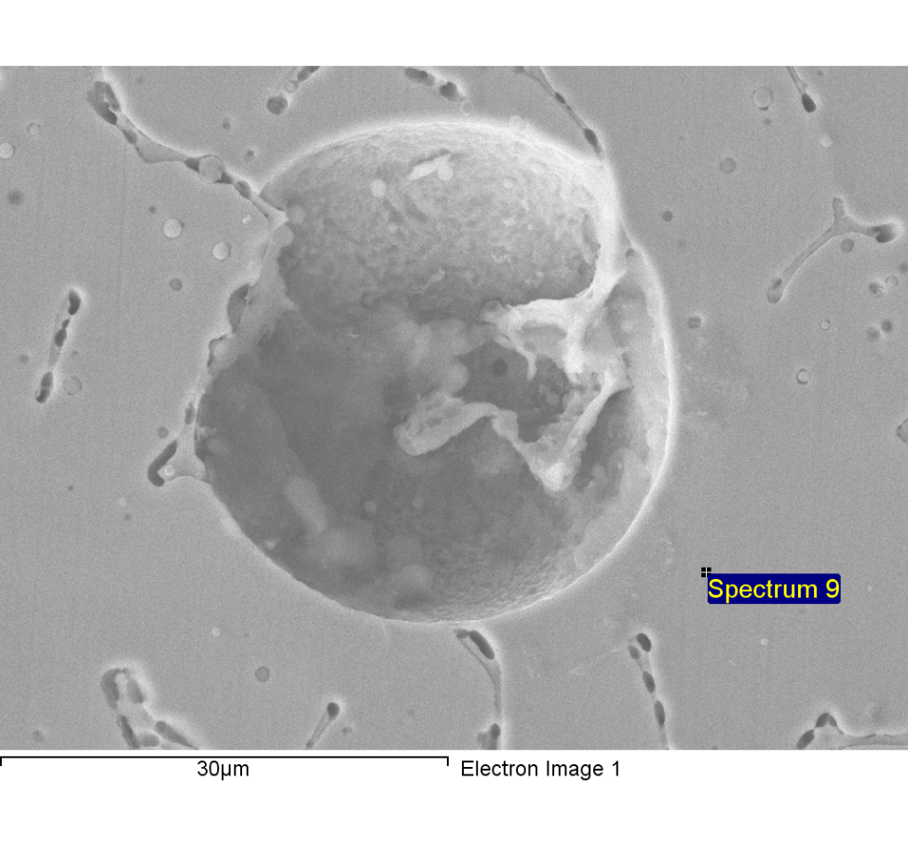

Comment:line1-5-point scan-9

|  |  |  |  |
| --- | --- | --- | --- |
| Element | Weight% | Atomic% |  |
|  |  |  |  |
| C K | 3.96 | 15.84 |  |
| Si K | 0.84 | 1.44 |  |
| Cr K | 20.36 | 18.80 |  |
| Mn K | 1.47 | 1.29 |  |
| Fe K | 62.73 | 53.93 |  |
| Ni K | 10.63 | 8.70 |  |
|  |  |  |  |
| Totals | 100.00 |  |  |

1/18/2018 5:12:42 PM

Project 2

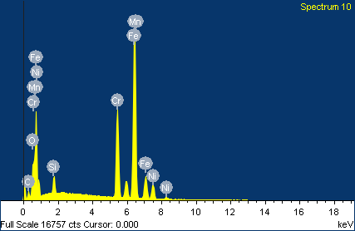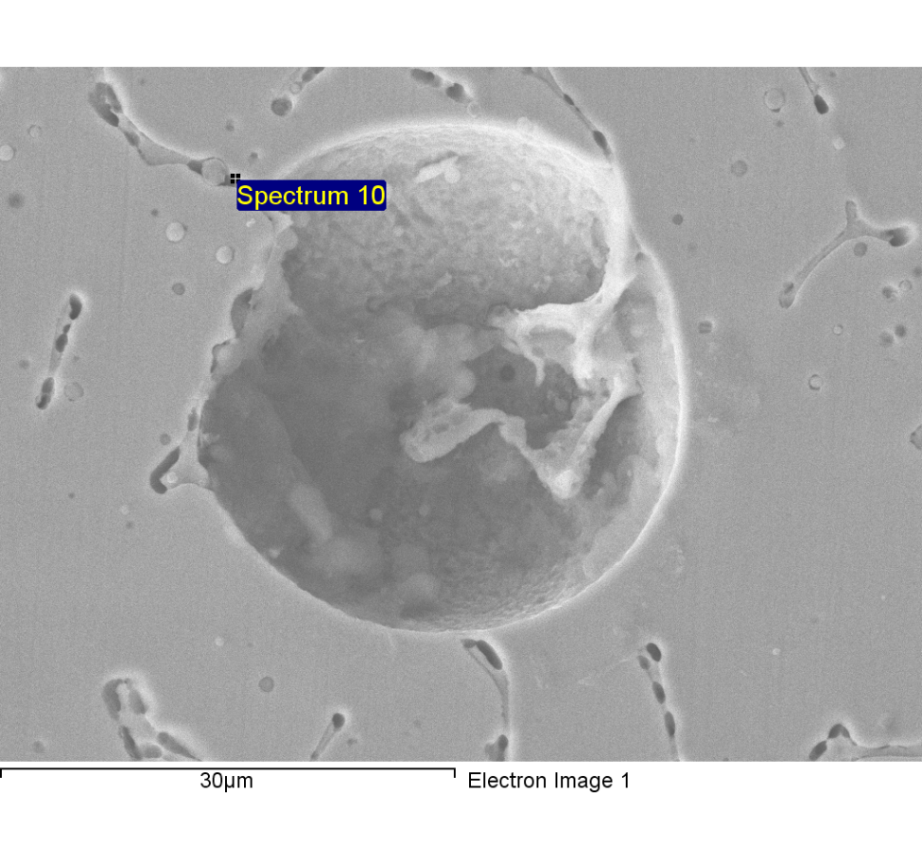

Comment:line1-5-point scan-10

|  |  |  |  |
| --- | --- | --- | --- |
| Element | Weight% | Atomic% |  |
|  |  |  |  |
| C K | 6.16 | 21.40 |  |
| O K | 3.31 | 8.64 |  |
| Si K | 2.01 | 2.98 |  |
| Cr K | 19.64 | 15.76 |  |
| Mn K | 1.97 | 1.50 |  |
| Fe K | 59.11 | 44.17 |  |
| Ni K | 7.80 | 5.54 |  |
|  |  |  |  |
| Totals | 100.00 |  |  |

1/18/2018 5:13:01 PM

Project 2